

**CATHOLIC UNIVERSITY OF EASTERN AFRICA**

**FACALTY OF SCIENCE**

**DEPARTMENT OF COMPUTER AND INFORMATION SCIENCE**

**HOTEL MANAGEMENT SYSTEM: A CASE OF SIRITAMU RESORT AND SPA**

**RODNEY MISOI KIPKEMBOI**

**ADM:1050932**

**A Project Submitted in Partial Fulfilment of the Requirements for the Award of Diploma in Information Technology**

**AUGUST, 2024**

# DECLARATION AND APPROVAL

STUDENT

I hereby declare that this research endeavour is wholly original with no submissions for academic credit made by anyone else to any other school, as far as I am aware.

Name: Misoi Rodney Kipkemboi

Reg/NO: 1050932

Signature: ……………………………. Date: ……………………………..

**UNIVERSITY SUPERVISOR’S APPROVAL**

This Project has been submitted for examination with my approval as a University Supervisor

Name: Doreen Mango

Signature: ……………………………. Date: ……………………………..

**HEAD OF DEPARTMENT’S APPROVAL**

This project has been submitted for examination with my approval as a Head of Department

Faculty of Computer Science at the Catholic University of Eastern Africa

Name: Mr Michael Kinyua

Signature: ……………………………. Date: ……………………………..

Department of Computer and Information Science.

# DEDICATION

Almighty God, whose divine providence has led me every step of the way, is the one to whom I dedicate this effort. I owe a debt of gratitude to my friends, family, and the instructors at the Catholic University of Eastern Africa in particular for their continuous encouragement and support. I appreciate all of your encouragement to follow and cling to my dreams.

# ABSTRACT

*The HOTEL MANAGEMENT SYATEM was developed following system development tags for smooth running and management of Siritamu Resort and Spa. After an information gathering process, the system analysist saw that the hotel indeed needed a computarized management system. The aim of a simple hotel management system (HMS) is to enhance the efficiency of hotel operations by automating key processes. This includes managing room availability, booking cornfamations, manage staff workflows, ensuring tasks are assigned and tracked effectively, thereby improving overall operational efficiency and customer service.. The system basically consists of two modules the user and administrative modules. The proposed system is focusing to solve the problem encountered at radix hotel such as manual cataloguing, The development of this system will be based on SDLC and the front end will be designed with PHP and HTML as the programming languages while MySQL server as the database of the system. HTML language is most preferred because it contains validation properties that will be used to design back end while MySQL has better features and properties, has good security, it’s ` an open source and has cross platform for good interaction and the PHP programming language will enable use of open source language, support the community interaction and it has built-in database connection modules which makes it easy to connect to the database.*

TABLE OF CONTENTS

DECLARATION AND APPROVAL i

DEDICATION ii

ABSTRACT iii

TERMS AND ABBREVIATIONS vii

CHAPTER ONE: INTRODUCTION 1

1.1: Introduction 1

1.2: Motivation Background 1

1.3: Problem Statement 2

1.3: Aim of the research 2

1.4: Objective of the research 2

1.5: Justification 2

1.6: Scope 3

1.7: Research Organization 3

CHAPTER TWO: REVIEW OF RELATED WORK 5

2.0: Introduction 5

2.1: Previous studies from Siritamu Resort and Spa 5

2.2: Review of related prototype, System 5

2.3: Emerging trends and patterns 6

2.5: Chapter summary 7

CHAPTER THREE: METHODOLOGY 8

3.1: Chapter introduction 8

3.2 Methodology for Literature Review 8

3.3: Methodology for Requirements Specification, Data Collection and Analysis Technology 9

3.3.1: Observation 9

3.3.2: Oral interviews 9

3.3.4: Questionnaires 10

3.4: Methodology for System Design 10

Database Design 11

3.5: Methodology for System Implementation: Backend, Frontend, and Database Technology 20

Development Tools and Technologies: 20

3.6: Methodology for System Testing Plan and Testing Techniques 21

3.7: Methodology for System Deployment 22

3.8: Chapter summary 23

CHAPTER FOUR: SYSTEM ANALYSIS 24

4.1: Introduction 24

4.2 Description of current Systems, its Strength and Weakness 24

4.2.1: Strength of the system 25

4.2. Weakness of the system 25

4.3: Feasibility Study and Conclusion 26

4.4: Manual system structure 27

4.6: Chapter conclusion 28

CHAPTER 5: SYSTEM DESIGN OF THE PROPOSED SYSTEM 29

5.1: Introduction 29

5.2: System description 29

5.3: Requirement analysis 30

5.3.1: Functional requirement 30

5.4: Architecture of the Proposed System 31

5.5: System design 32

5.6: Database Design ERD, Normalization and Data Dictionary 33

CHAPTER SIX: SYSTEM TESTING AND IMPLIMENTATION 34

6.1: Introduction 34

6.2: System Screenshots 34

Figure 6.2.2: Admin homepage screenshot 35

6.3: Outline of the Testing Strategy 41

6.4: The Software Test Plan's Goals 41

6.5: Conclusion 41

CHAPTER SEVEN: CONCLUSION, FINDINGS AND RECOMMENDATION 42

7.1: Introduction 42

7.2: Conclusion 42

7.3: Challenges encountered 42

7.4: Future recommendations 43

7.5: Chapter summary 43

APPENDICES 44

Appendix I: Sample Questionnaire 44

Appendix 2: Sample code 46

Sample code 46

REFERENCES 52

# TERMS AND ABBREVIATIONS

Application Programming Interface (API)

Database Management System (DBMS)

User Interface (UI)

Structured Query Language (SQL)

Artificial intelligence (AI)

Hotel management system (HMS)

Hypertext Processor (PHP)

Integrated Development Environment (IDE)

Data Flow Diagram (DFD)

Entity Relationship Diagram (ERD)

Hypertext Mark-ups Language (HTML)

My Structured Query Language (MYSQL)

# CHAPTER ONE: INTRODUCTION

## 1.1: Introduction

In this chapter, the researcher will explore the motivation and background for the development of a computerized Hotel Management System (HMS). The discussion will focus on the context of Siritamu Resort and Spa, outlining the limitations of the current manual systems in use. The chapter will detail the problem statement, emphasizing the inefficiencies, such as time-consuming tasks, data inaccuracies, and operational challenges associated with manual processes. Additionally, the justification for transitioning to a computerized system will be presented, highlighting how automation can enhance administrative efficiency. Finally, the chapter will outline the research organization, including the strategies for improving the HMS and the methodologies for system implementation and evaluation.

## 1.2: Motivation Background

In this chapter, the researcher will explore the evolution of hotel management systems, tracing their development from rudimentary beginnings in the early 20th century to the sophisticated, integrated solutions available today. Initially, early systems were isolated and had limited functionality. However, advancements in software and the advent of the internet have led to more comprehensive and integrated solutions. Recently, the focus has shifted towards leveraging smart technology, including Artificial Intelligence (AI) and machine learning algorithms, to enhance operational efficiency and user experience through advanced statistical analysis and insights into user preferences.

The purpose of this study is to evaluate the current hotel management system in place at Siritamu Resort and Spa, identify the challenges faced by hotel owners, and propose innovative solutions to improve the system's efficacy and efficiency. To address the issues inherent in manual systems, a web-based hotel management system has been developed. This software is designed to mitigate the difficulties associated with manual operations, reduce the handling of physical documents, and streamline processes. It features a centralized database for managing guest and staff information, aiming to provide an error-free, secure, reliable, and efficient management solution.

The proposed system will assist hotel staff in delivering a memorable guest experience by allowing them to focus more on service quality rather than administrative tasks. By adapting to the specific needs of Siritamu Resort and Spa, including payment processing, check-ins, and staff management, the system will help optimize resource utilization and enhance overall operational performance.

## 1.3: Problem Statement

The current manual system for reservations, check-ins, inventory management, and overall administration results in significant inefficiencies and errors, impeding the hotel's ability to deliver a seamless guest experience. Despite the hotel's international standards, it is not achieving its full potential due to delays and issues stemming from the outdated manual processes. Frequent errors have led to considerable financial losses, prompting the hotel management to adopt a computerized system. This new system is designed to be more user-friendly for both customers and staff, improve customer service, enhance overall hotel performance, and reduce operational costs.

## 1.3: Aim of the research

The aim of this research is to develop a hotel management system that leverage modern technologies to enhance operational efficiency and improve data management.

## 1.4: Objective of the research

1. Allow users to add employee details.
2. Facilitate room allocation to guests.
3. Enable job assignments for employees.
4. Permit users to add customer details

## 1.5: Justification

This research aims to develop a hotel management system that leverages modern technologies to enhance operational efficiency and improve data management. The study will provide insightful information and practical solutions that can assist Siritamu Resort and Spa operators in streamlining their operations, enhancing guest satisfaction, and achieving sustainable growth. The increasing demand for an efficient and effective hotel management system in the hospitality industry motivates this research, as hotels must adopt modern technologies to remain relevant and competitive. By enabling functionalities such as adding employee details, facilitating room allocation to guests, enabling job assignments for employees, and permitting the addition of customer details, the proposed system will address key operational challenges faced by hotel management. This will ultimately lead to improved service delivery, better resource management, and a more satisfying experience for guests, positioning Siritamu Resort and Spa as a leader in the hospitality sector.

## 1.6: Scope

The HMS designed for Siritamu Resort and Spa aims to comprehensively manage crucial information, including employee details, guest information, job assignments, room specifics, booking records, job descriptions, and payment information. By automating these processes, the system will significantly enhance the efficiency of hotel operations, allowing staff to focus more on providing exceptional guest services and improving overall hospitality. Additionally, the system will streamline the management of additional facilities, ensuring a holistic approach to hotel operations. It will cover all essential aspects of hotel management, including bookings, accommodation, and accounts, thereby offering a cohesive and integrated solution that boosts operational efficiency and enhances the guest experience.

## 1.7: Research Organization

Chapter One outlines the motivations behind developing a computerized Hotel Management System (HMS) for Siritamu Resort and Spa. The primary goal is to transition from a manual system, which hampers efficiency and accuracy, to a streamlined digital solution that improves guest service and operational effectiveness. This system is designed to handle employee details, guest information, job assignments, room management, bookings, and payments, thereby allowing staff to concentrate on enhancing guest experiences. The chapter will also address the issues with the current manual system, the aim of the research, and the objectives to create a more efficient and user-friendly system. The justification highlights the system's potential to reduce paperwork, increase efficiency, and secure data management. The scope will define the boundaries of the research, and the organization will detail the methodology for achieving these improvements.

Chapter Two reviews the evolution of hotel management systems both globally and locally, highlighting technological advancements that have influenced the industry. It will examine existing prototypes and systems, focusing on emerging trends such as smart technology and AI integration that improve operational efficiency and user experience. The chapter will identify gaps in current research and propose how this study will address these gaps by offering innovative solutions to enhance hotel management practices.

Chapter Three details the research methodology, including the principles and procedures guiding the study. It will cover the literature review process, requirement specification, data collection methods such as interviews and questionnaires, and analysis techniques. The methodology for system design and implementation will be outlined, using tools like flow charts, sequence diagrams, and pseudocode. The chapter will also address system testing, deployment strategies, and the systematic approach to ensuring the new HMS meets quality standards and user expectations.

Chapter Four provides a comprehensive analysis of the current hotel management system, evaluating its strengths and weaknesses. The chapter will analyze data input and output, detailing the relationships and flow of information within the system using various diagrams such as context diagrams and data flow diagrams (DFDs). The chapter will conclude with a summary of the system analysis findings.

Chapter Five focuses on the design of the proposed HMS, detailing its structure and functionality. It will describe the system’s strengths and weaknesses, functional and non-functional requirements, and conceptual architecture. The chapter will include process logic design through use case diagrams, activity diagrams, sequence diagrams, and class diagrams. It will also cover database design, including entity-relationship diagrams (ERDs), normalization, and data dictionaries. Additionally, mock-up screens will illustrate the system's interface and user interactions.

Chapter Six addresses the implementation of the HMS, turning theoretical designs into a functional system. It will involve planning, preparation, and execution of the system rollout, including training for end users. The chapter will present screenshots of the system. The implementation process will include a review of the current system’s constraints and how the new system will be integrated with minimal disruption.

Chapter Seven summarizes the research findings, presenting conclusions drawn from the study. It will discuss challenges encountered during the research and implementation phases and provide recommendations for future improvements. The chapter will conclude with a summary of the overall research, reflecting on the impact of the new HMS on Siritamu Resort and Spa and suggesting areas for further research and development**.**

# CHAPTER TWO: REVIEW OF RELATED WORK

## 2.0: Introduction

An extensive overview of prior studies and literature on hotel management systems is provided in this chapter. By examining the history of hotel management systems, looking at related prototypes and systems from local to global perspectives, spotting emerging trends and patterns in the field, and emphasising the research gap that this study aims to fill, this review seeks to contextualise the current study within the framework of earlier developments. The purpose of this chapter is to demonstrate the current research's importance and applicability in the larger hotel management setting.

## 2.1: Previous studies from Siritamu Resort and Spa

Employees at hotels have been tasked in recent years with gathering information from agents by giving them printed forms to complete. Their responsibilities now include this process on a regular basis, which calls for the careful gathering, handling, and archiving of data. Ensuring that pertinent and accurate information reaches the right people and organisations at the correct time and location is the aim. However, the requirement to manually process a sizable number of policy documents every day is placing a rising load on the company's staff and clients, resulting in inefficiencies and resource pressure.

## 2.2: Review of related prototype, System

At the local, regional, and international levels, there have been major contributions made to the development of hotel management systems. Systems like Micros Fidelio, Protel PMS, and Oracle Hospitality's OPERA Cloud have established industry standards on a global scale. These systems provide all-inclusive solutions that handle financial reporting, housekeeping, and front desk operations in addition to reservations. Large hotel chains have embraced them widely, and they have greatly influenced the development of the HMS industry today.

These global systems have been adapted locally to satisfy particular legal and cultural requirements. For example, several systems in Europe have been connected with the GDPR compliance function to guarantee data protection and privacy. In order to serve a varied clientele, the integration of local payment methods and multilingual assistance has been the main priority in Asia.

Smaller hotel chains and independent hotels frequently utilise customised systems that cater to particular needs locally. Examples include regional software programs like Hotelogix, which is well-liked by small and medium-sized hotels in developing nations because of its user-friendliness and low cost. These systems frequently provide basic functionalities with streamlined user interfaces, enabling even non-technical individuals to utilise them.

## 2.3: Emerging trends and patterns

Innovations in technology and shifting customer demands have created a number of new trends and patterns in the hotel management system industry. Some of the trends are:

**Cloud based systems:** Cloud technology is becoming increasingly popular, offering hotels flexibility and scalability. Cloud-based HMS allow for real-time updates, remote access, and easier integration with other systems, which is crucial for managing multiple properties or locations.

**Integration of artificial intelligence**: Chatbots driven by artificial intelligence, demand forecasting through predictive analytics, and customized visitor experiences are quickly becoming commonplace. Hotels may increase operational efficiency, improve customer service, and optimize pricing strategies with the help of these technology.

**Data Analytics and Reporting:** To assist hotels in analysing visitor preferences, booking patterns, and financial performance, sophisticated data analytics capabilities are being included into HMS. This makes it possible to make better decisions and implement more focused marketing plans.

**Mobile Optimisation**: Both employees and visitors need to have access to mobile-friendly systems and apps. The increasing prevalence of mobile check-ins, digital key cards, and mobile concierge services improves both the visitor experience and operational effectiveness. A thorough overview of the development and status of hotel management systems is given in this chapter. It has outlined the evolution of HMS, examined relevant systems and prototypes at all scales, from the international to the local, and discovered new patterns and trends that will influence the sector going forward.

## 2.5: Chapter summary

A thorough overview of the development and status of hotel management systems is given in this chapter. It has outlined the evolution of HMS, examined relevant systems and prototypes at all scales, from the international to the local, and discovered new patterns and trends that will influence the sector going forward.

# CHAPTER THREE: METHODOLOGY

## 3.1: Chapter introduction

Research methodology encompasses a broad range of dimensions and methods, extending beyond specific research methods. It involves the fundamental principles and rules guiding the research process, while research methods are systematic procedures for conducting specific activities. This chapter will delve into the methodology for literature review, focusing on new developments and ensuring consistency in research activities. It will also cover information collection techniques, including questionnaires and interviews. Additionally, the chapter will outline the methodology for implementing the system, detailing both backend and frontend development, as well as database technologies. This approach aims to demonstrate the systematic flow of the proposed system and its components.

flow of the proposed system and its components.

## 3.2 Methodology for Literature Review

The development and evolution of hotel management systems have been significantly influenced by the advancement in digital technologies, which have introduced both opportunities and challenges in the hospitality industry. The transition from traditional paper-based systems to computerized solutions has revolutionized the way hotels operate, enhancing efficiency, customer satisfaction, and overall management capabilities. This literature review aims to explore these advancements and their impact on hotel management systems, focusing on how these systems have evolved to meet the changing needs of the industry.

Over the years, digital innovations have provided hotels with the tools to manage their operations more effectively, from room bookings to customer service. These advancements have been driven by the need to improve operational efficiency, provide better customer experiences, and leverage data for strategic decision-making (Sanchez-Rebull et al., 2018). The shift towards digital hotel management systems allows for streamlined operations, real-time data access, and improved communication between departments, which are essential in today's fast-paced hospitality environment.

Past studies have shown that the adoption of hotel management systems leads to higher customer satisfaction by providing transparent information, improving service delivery, and offering personalized experiences (Melian-Gonzalez & Bulchand-Gidumal, 2016). The literature also emphasizes the role of these systems in helping hotels manage their resources more efficiently, reducing operational costs, and increasing profitability.

In summary, this literature review will explore the various facets of hotel management systems, focusing on their impact on customer satisfaction, operational efficiency, and the overall evolution of the hospitality industry in the digital age. The review will draw on a wide range of sources to provide a comprehensive understanding of the current state of hotel management systems and their future directions.

### 3.3: Methodology for Requirements Specification, Data Collection and Analysis Technology

### 3.3.1: Observation

The researcher closely monitored the hotel management’s performance and customer handling during their stay. It became evident that the hotel urgently needed to automate its operations to fully realize its potential. The existing manual system for managing bookings was insufficient, prompting the researcher to devise a solution that would clearly delineate the management responsibilities of different departments. The guest payment process also required immediate improvement, as it was causing delays and inefficiencies at the accountant's desk. Additionally, the researcher observed that visitor records were not accurately maintained and were vulnerable to unauthorized access, highlighting the need for enhanced security measures.

## 3.3.2: Oral interviews

This was the data collection method that was most exhaustible. During the data collecting process, the team employed their exceptional data collection abilities to obtain information from the hotel's staff, guests, and management team. Among the information gathered, the following stood out as being extremely important: The opinions of the staff regarding the suggestion to implement a new computerised system, as well as the feelings of the guests with the hotel's current management. Many employees who were not computer literate were afraid that they would be replaced or replaced by more computer literate personnel, but they were reassured that they would still be employed if they could demonstrate their competency in their current roles. The system took into account the management's urgent requirement to oversee the hotel's operations.

## 3.3.4: Questionnaires

Users who regularly engage with the present system were given questionnaires to complete in order to obtain a comprehensive grasp of its strengths and drawbacks. The researcher was able to determine the system's efficiencies and inefficiencies by closely examining their input. The procedure played a pivotal role in ascertaining the precise prerequisites that the suggested system must fulfil to enhance the current framework.Sample: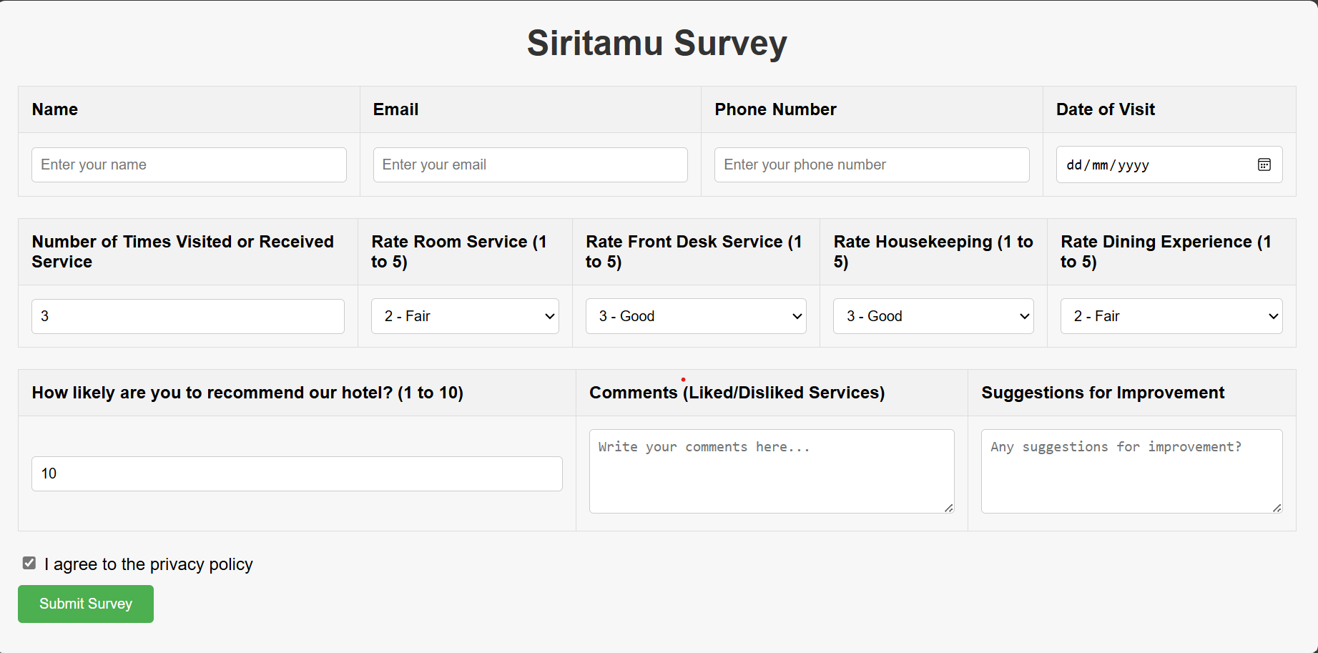

Figure3.3.4.1: sample of questionnaires

## 3.4: Methodology for System Design

The methodology for system design, database design, context diagram, flow chart, and sequence diagram is critical in developing a comprehensive Hotel Management System (HMS). The HMS is a software application that facilitates the efficient management of hotel operations, including room bookings, customer check-ins and check-outs, billing, and service management. It aims to enhance user experience for both hotel management and guests by providing features such as check-ins and secure payment processing.

The design process begins with creating a context diagram that outlines the interactions between the HMS and external entities, such as guests, hotel staff, and payment gateways. This visual representation helps in understanding the system's boundaries and its relationship with other systems. Flow charts are then developed to illustrate the various processes involved, such as the booking procedure, payment processing, and customer check-in/check-out workflows.

Ultimately, the system design methodology prioritizes adaptability and flexibility to meet evolving user needs and potential challenges during implementation. By considering user experience and operational efficiency, the HMS aims to foster a seamless interaction between hotel management and guests, leading to increased satisfaction and loyalty.

## Database Design

The database for the Hotel Management System (HMS) at Siritamu Resort and Spa is designed to efficiently store and retrieve data, ensuring that information is readily accessible when needed. The chosen database management system for implementing the back end of the HMS is MySQL, with access facilitated through a graphical user interface, phpMyAdmin. The database is named "hoteldb" and will include the following tables:

File data field:

**Advance table**

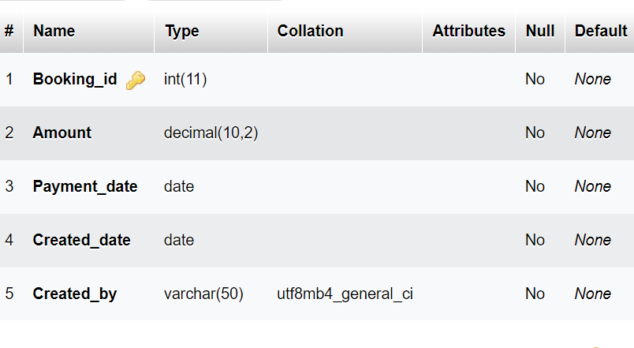

**Billing Table**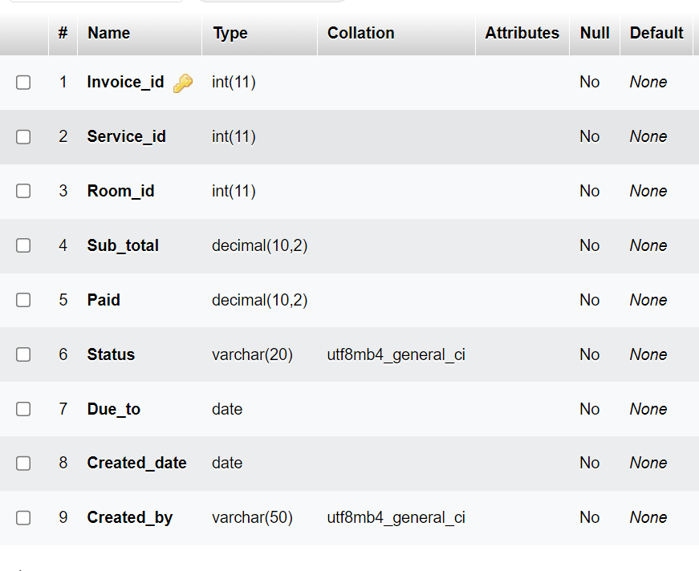

**Bill master table**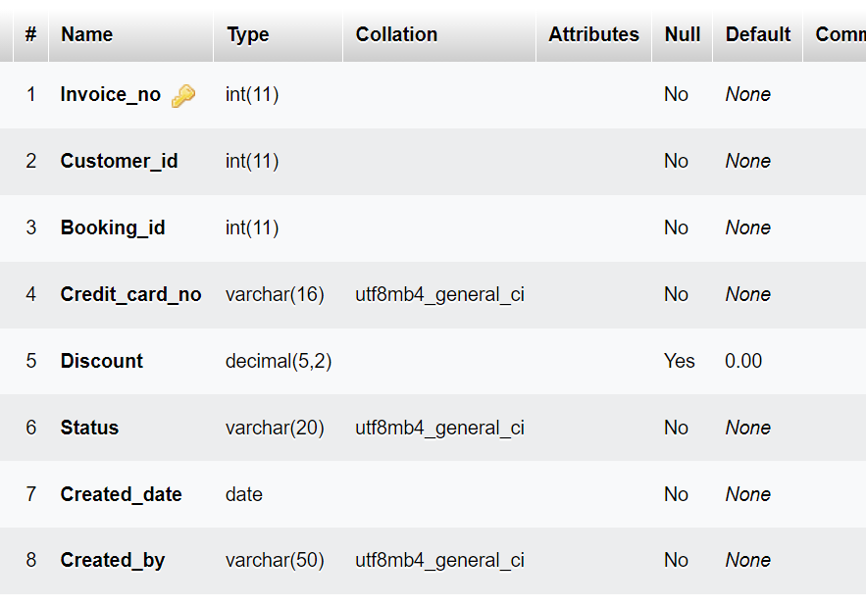

**Booking table**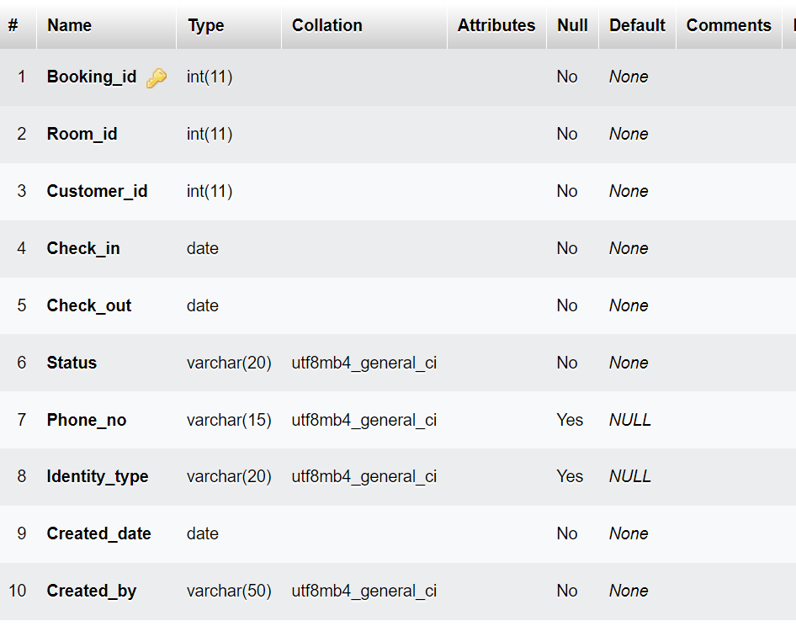

**Customer Table**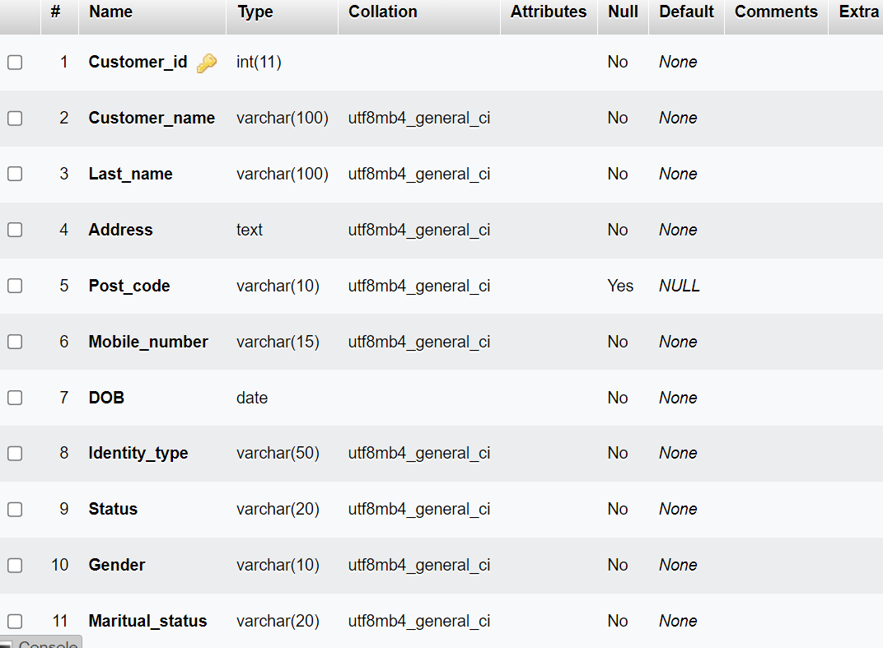

**Department Table**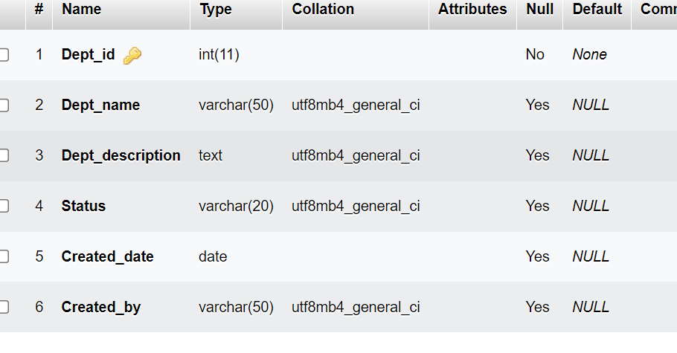

**Employee table**

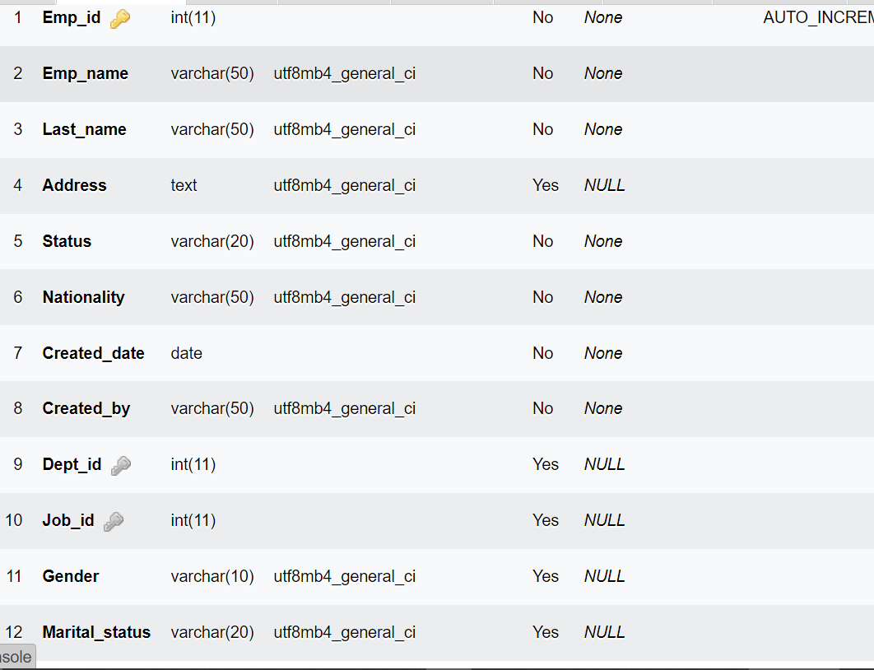

**Hotel table**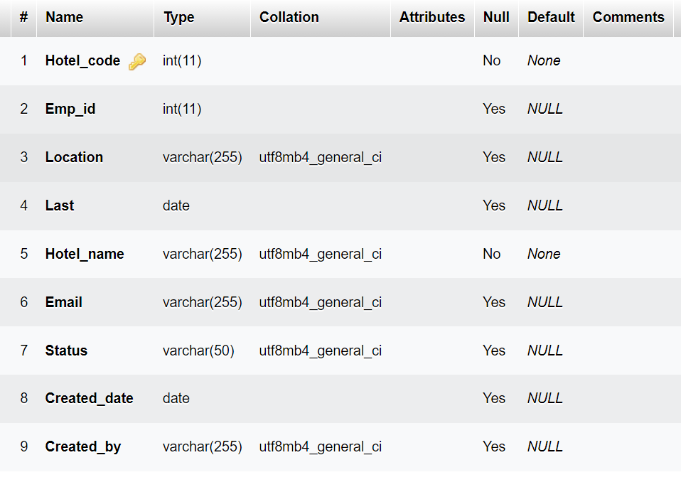

**Job table**

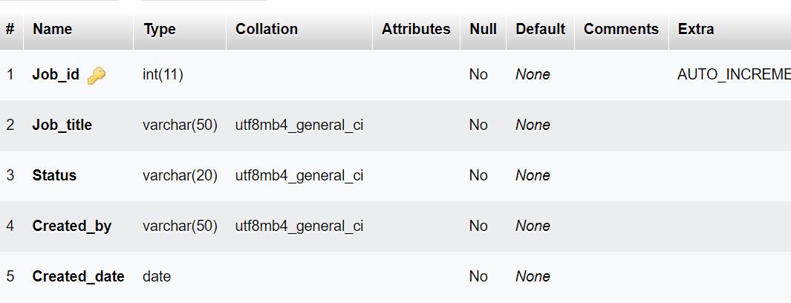

**Payment table**

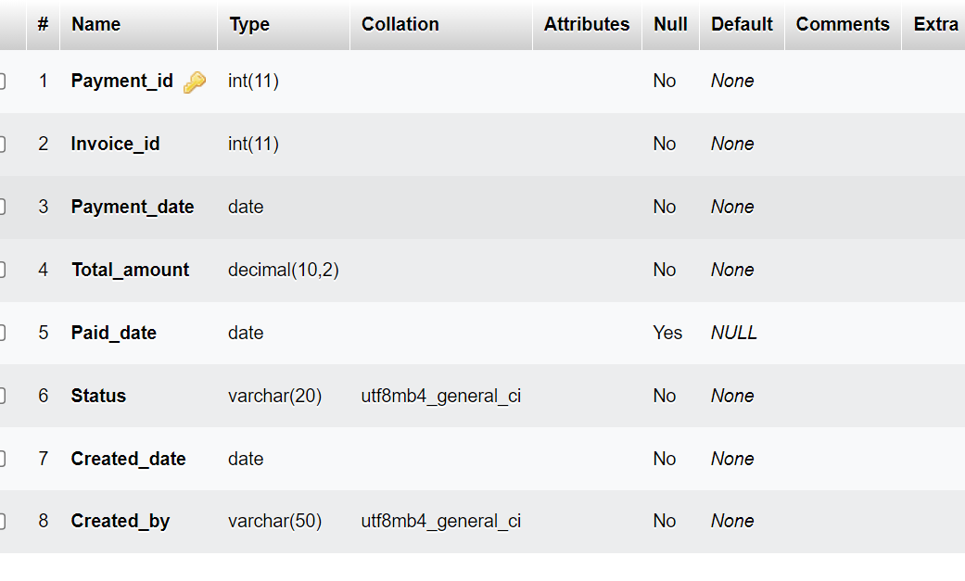

**Room table**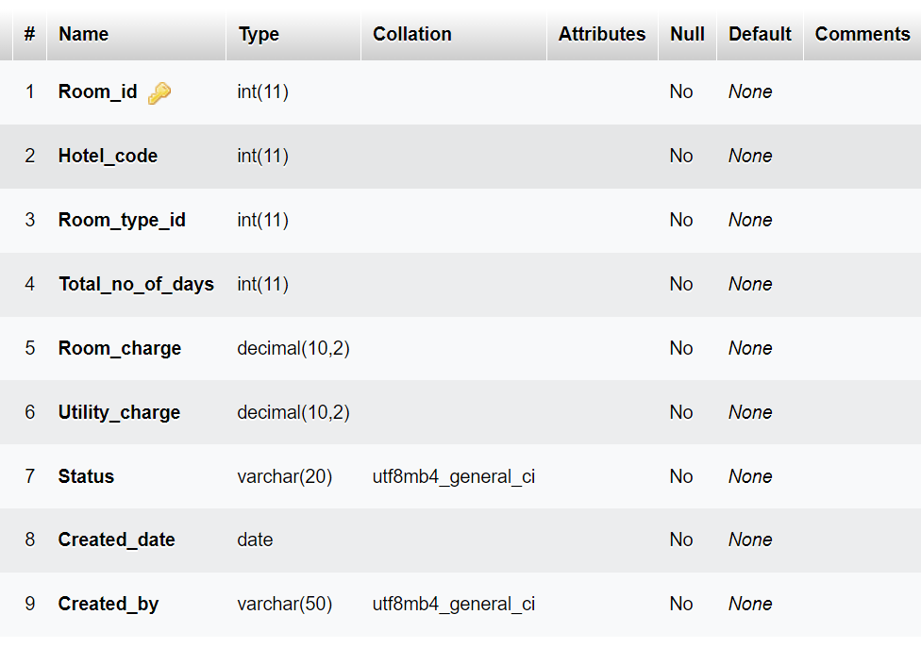

**Room type table**

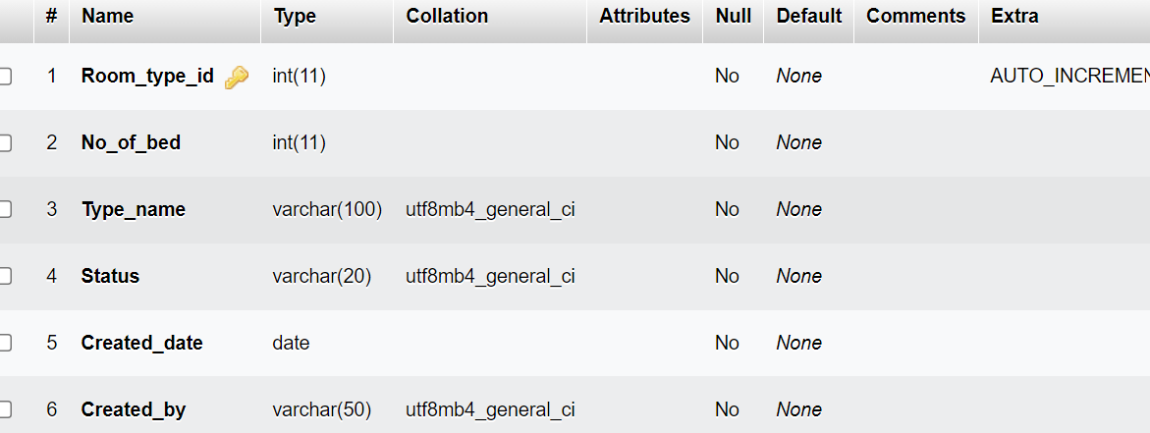

**Service table**

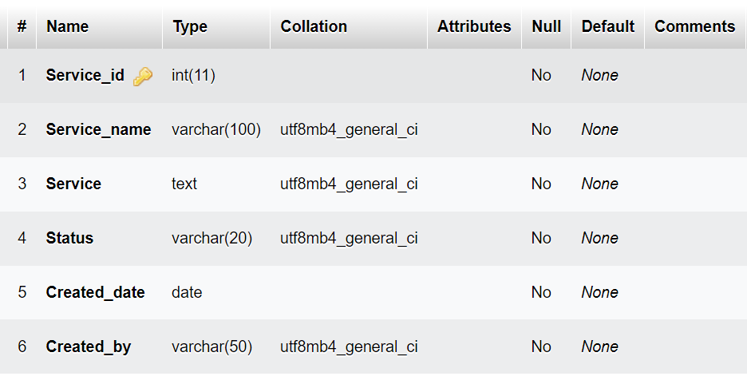

## 3.5: Methodology for System Implementation: Backend, Frontend, and Database Technology

The development of the Hotel Management System (HMS) employed the **Agile methodology** under the Software Development Life Cycle (SDLC). Agile was chosen for its iterative and flexible approach, allowing the project to adapt to changing requirements and feedback throughout the development process. Agile emphasizes continuous collaboration, customer involvement, and incremental delivery of functional software, ensuring that the system evolves to meet the needs of the hotel management effectively.

Agile divides the project into small, manageable iterations called sprints, each typically lasting two to four weeks. At the end of each sprint, a working component of the system is delivered, tested, and reviewed. This approach allows for regular assessment and refinement, ensuring that the final product is robust, user-friendly, and aligned with the hotel’s operational requirements.

## ****Development Tools and Technologies:****

**Visual Studio Code**: Visual Studio Code was selected as the Integrated Development Environment (IDE) for developing the Hotel Management System. It supports multiple programming languages and offers a range of features like live debugging, version control, and an extensive library of extensions, which are essential for agile development. Its flexibility allows developers to work efficiently across various sprints, adjusting and optimizing the codebase as new features are added or existing ones are refined.

**MySQL**: MySQL was chosen as the database management system for the HMS. Its reliability and scalability make it ideal for handling the dynamic data requirements of a hotel, such as room bookings, customer records, and billing information. MySQL's ability to handle large volumes of transactions and its compatibility with PHP and other tools make it a critical component in the iterative development process, enabling quick adjustments to database schemas as needed.

**PHP**: PHP was utilized for backend development, enabling the creation of dynamic web pages that interface seamlessly with the MySQL database. In an agile context, PHP’s flexibility allows for rapid development and integration of new features, making it easier to respond to user feedback and evolving project requirements. PHP's extensive library of functions and strong community support facilitate quick iteration and problem-solving during the development process.

**JavaScript**: JavaScript was used to create interactive and responsive elements within the HMS. It plays a crucial role in enhancing the user experience by enabling real-time updates, dynamic content, and interactive dashboards. Agile development benefits from JavaScript's versatility, allowing developers to quickly prototype and implement features that improve the system’s usability and interactivity with each sprint.

**CSS**: CSS was employed to style and layout the web pages, ensuring a consistent and visually appealing interface for the HMS. In Agile, where user feedback and interface adjustments are frequent, CSS allows for rapid changes to the system’s design without disrupting the underlying functionality. This capability is vital for maintaining a professional and user-friendly appearance across various devices and screen sizes, even as the system evolves through multiple iterations.

By using Agile methodology, the development of the Hotel Management System was highly collaborative and adaptable, ensuring that the system met the evolving needs of hotel management. The combination of Visual Studio Code, MySQL, PHP, JavaScript, and CSS facilitated this process, allowing for continuous improvement and delivery of a functional and user-centric system.

# 3.6: Methodology for System Testing Plan and Testing Techniques

The testing plan for the Hotel Management System (HMS) is focused on ensuring the usability and user experience of the application. The primary goal of the testing process is to validate that the system is intuitive, easy to navigate, and accessible, allowing users to perform essential tasks such as booking rooms, checking availability, making payments, and managing reservations without any confusion or frustration.

Key factors considered during the testing process include:

**Ease of Use**: Ensuring that the interface is user-friendly, allowing both guests and staff to navigate the system with minimal effort.

**Intuitive Design**: Verifying that the layout and design of the system are logical and straightforward, enabling users to complete tasks efficiently.

**Clear Navigation**: Testing the system’s navigation to ensure that users can easily find what they are looking for, such as room options, booking forms, and payment gateways.

In addition to front-end usability, the testing plan also includes rigorous back-end testing to ensure that the system's database functions correctly. Although the user does not interact directly with the database, it is a critical component of the system. The database testing process involves:

**Data Integrity**: Ensuring that data is accurately stored, retrieved, and updated within the database.

**Performance Testing**: Evaluating the database's performance under various conditions, such as high traffic and multiple simultaneous queries.

This comprehensive testing plan aims to deliver a Hotel Management System that not only meets the operational needs of the hotel but also provides a seamless and satisfying experience for users.

# 3.7: Methodology for System Deployment

System deployment for a Hotel Management System (HMS) involves a systematic approach to deliver a new or updated software solution to stakeholders, ensuring it meets their requirements while integrating seamlessly into the existing operational environment. Key steps include meticulous planning to identify the hotel's specific needs, timelines, and resource allocation, alongside a comprehensive risk management plan. Thorough testing ensures compatibility and performance, followed by installation and configuration tailored to the hotel's workflows. Training is critical for hotel staff and management to foster proficiency and minimize disruptions during the transition. Finally, ongoing support post-deployment addresses issues, assists users, and incorporates regular updates, ultimately enhancing operational efficiency and user satisfaction while minimizing risks and disruptions.

3.7.1Project Schedule

|  |  |  |  |  |  |  |  |  |
| --- | --- | --- | --- | --- | --- | --- | --- | --- |
| **Activity/Month** | **Jan** | **Feb** | **Mar** | **Apr** | **May** | **Jun** | **JuL** |  |
| **Project proposal** |  |  |  |  |  |  |  |  |
| **Field Study** |  |  |  |  |  |  |  |  |
| **Analysis** |  |  |  |  |  |  |  |  |
| **Design** |  |  |  |  |  |  |  |  |
| **Coding** |  |  |  |  |  |  |  |  |
| **System testing** |  |  |  |  |  |  |  |  |
| **Project Release** |  |  |  |  |  |  |  |  |
| **Project documentation** |  |  |  |  |  |  |  |  |

Figure 3.7.1.1: project schedual

## 3.8: Chapter summary

The research methodology used to create the hotel management system is described in Chapter 3. The team gathered information through observation, interviews, and questionnaires and determined that the current manual approach was inefficient and needed to be automated. Staff worries regarding job security were brought up in interviews, while system shortcomings were brought up in questionnaires. Data problems discovered during document modifications prompted the development of an error recovery plan for the new system to guarantee data integrity.

# CHAPTER FOUR: SYSTEM ANALYSIS

## 4.1: Introduction

This chapter offers a thorough examination of the present hotel management system, pointing out both its advantages and disadvantages. Along with flow charts, context diagrams, and data flow diagrams (DFDs) to support the process logic design, it also comprises a feasibility assessment and an analysis of data input/output. A summary of the results wraps up the chapter.

## 4.2 Description of current Systems, its Strength and Weakness

The hotel is now managed using a manual system that consists of paperwork and oral direct human language connection. This causes a lag in the hotel's information flow.

Reservations can be made over the phone or in person at the hotel booking office. Personal information about the visitor, including name, age, nationality, and length of stay, is entered at the time of check-in. Prior to the guest's check-in date, the booking office places orders for the guest's room to be prepared.

The paperwork is manually moved to the filling department so that the guest's file can be assembled. The file gets moved to the reception on the reporting date. The guest receives the key to the room that is assigned to him upon check-in, and he can also indicate whether he wants room service.

The accountant at the next table receives the guest's file from the receptionist. Here, the visitor covers the cost of lodging and meals. Every day, the guest's file is updated with his expenses. Every day, the accounts department produces the bills, which are then handed by the service maids to the guests in their rooms at dusk. At the accounts counter, where receipts are generated, the guest makes their payment.

When a customer orders a single meal, the bill is generated right away, and he pays the accountant before heading out.

A day before to the guest's check-out date, their expenditure outlines are generated. As they check out, visitors pick up their forms from the accounts desk and settle any outstanding debts.

In order to determine if it would be feasible to replace the current manual hotel management system with a computerized one, a feasibility study was carried out with an emphasis on operational, technological, and financial aspects. Despite being easy to use, the manual method has a number of serious problems that impair the hotel's effectiveness and general performance.

### 4.2.1: Strength of the system

No Requirement for Advanced Computer expertise: Staff members can utilise the manual system without the need for specialized computer expertise, making it available to all members of the organization

Independence from Technology: Unlike computers, which might malfunction or fail, the manual system is not dependent on them. This lowers the chance that operations may be disrupted by technical problems.

Low Operating expenses: Since the manual method doesn't require energy, internet access, or other technological infrastructure that computerized systems require, it has lower operating expenses than computerized systems.

### Weakness of the system

Having Trouble Finding Guest Files: Hotel staff have a hard time finding guest files because of their sheer number when it comes to check-in, daily expense updates, receipt generation, and check-out processes. Delays and inefficiencies follow from this.

Overabundance of Storage Space: Two full rooms are full of storage cabinets housing the actual files. Instead of being used for activities that generate revenue, this space is taken up by the manual filing system.

Computational and Human Errors: The manual system's need for laborious calculations during data processing results in a high frequency of human errors. Hotel managers must pay a high price for these mistakes.

Inadequate Record Generation: The manual method frequently leaves out crucial information, including the specifics of a guest's luggage, leading to incomplete records. The consequences of this omission could be grave security risks, such as armed robbery.

Guest complaints: Inadequate document management has resulted in a number of complaints from guests, including overcharging and invoicing for services that were not utilized. The hotel's reputation is harmed by this.

Inadequate Communication: When departments fail to communicate with one another, guests end up receiving services they did not ask for, which leaves them confused and unhappy.

Data Analysis Difficulties: Due to insufficient or missing records, accountants find it difficult to analyze guest data and produce accurate expenditure bills, which further complicates financial management.

## 4.3: Feasibility Study and Conclusion

Technical Factors: The manual system's reliance on physical files leads to inefficiencies. For example, it can be challenging to find guest files while checking people in and out or updating daily expenses. Additionally, the sheer amount of files necessitates unnecessary storage space, taking away spaces that could be utilized for activities that generate revenue. Furthermore, the manual method is prone to computational and human error, particularly in data processing, which results in expensive errors for the hotel.

*Economic Factors*: The manual method requires no internet, energy, or sophisticated technology infrastructure, so its operational costs are lower initially, but there are substantial hidden costs related to its inefficiencies. Financial losses and mismanagement are caused in part by human mistake, subpar record keeping, and challenges with data analysis. Additionally, there is a significant financial disadvantage when precious space is used for storage rather than for earning money. This is known as the opportunity cost.

*Operational Factors:*

Operationally, the manual system's shortcomings are evident in several areas. Poorly managed records result in guest complaints, with instances of overcharging and incorrect billing damaging the hotel's reputation. Ineffective communication between departments often leads to guests receiving services they did not request, causing confusion and dissatisfaction. Additionally, the manual system's fragmented data capture and lack of integration make it difficult for accountants to analyze guest data accurately, complicating financial management.

The feasibility analysis came to the conclusion that the hotel must switch to a computerized system in order to overcome these obstacles. It is also viable to do so. The advantages of a computerized system, which include enhanced productivity, accuracy, data security, and spatial utilization, greatly surpass the expenses related to setup and training. Having a computerized system would simplify operations, cut down on mistakes, raise customer satisfaction, and eventually boost the hotel's earnings and standing.

## 4.4: Manual system structure

BOOKING

OFFICE

ACCOMMODA

TION

DEPARTMENT

ACCOUNTING

RECETION

GUEST FILES

STORAGE

GUEST BILLS &

EXPENDITURE

OUTLINES

BOOKING BY PHONE

CALL & VISIT

Figure 4.4.1: structure of the current manual system

## 4.6: Chapter conclusion

The investigation came to the conclusion that it is both required and practicable to replace the manual system with a computerized one. In the end, a computerized system would greatly increase visitor pleasure, streamline operations, increase the hotel's profitability and reputation, and improve efficiency, accuracy, data security, and space utilization.

# CHAPTER 5: SYSTEM DESIGN OF THE PROPOSED SYSTEM

## 5.1: Introduction

An overview of the project is given in this section, along with information on the background, main goals, and significance of creating the suggested system. It highlights the difficulties the existing system faces and stresses the demand for a more effective, dependable, and user-friendly fix.

## 5.2: System description

The goal of the suggested computerised hotel management system is to improve the accuracy, and efficiency of hotel operations. Key workflow operations like scheduling, invoicing, and record keeping are automated by the system, which also lowers the possibility of human error. Because of its strong design, it can be easily integrated with other services and scaled in the future, making it flexible enough to meet changing needs.

Benefits of the System:

Numerous advantages provided by the system greatly enhance hotel operations.

Simple and Quick Access to Files: A seamless check-in and check-out procedure is ensured by the speedy retrieval of guest information.

superior Data Management: The system makes sure that all records are correct and current by offering superior data management capabilities.

Decreased Visitor Congestion: More efficient booking and administration procedures lessen visitor congestion, which raises the standard of service as a whole.

Simple Record Updates: It is simple to update guest records, guaranteeing that all data is up to date and correct.

Higher Customer Service Standards: As a result of increased accuracy and efficiency, the hotel is able to provide better customer service, which draws in more visitors.

Errors in Data Entry and Processing: Automated operations greatly lower the chance of errors, increasing operational effectiveness.

Decrease in Paper Use: By minimising the requirement for paper records, the system helps to reduce clutter and promote environmental sustainability.

Although the system has many benefits, there are many drawbacks as well:

System Entropy and Maintenance Expenses: In order for the system to remain competitive over time, it will need to be updated on a regular basis, which will increase maintenance expenses.

Increased Utility Bills: As a result of computerising its management procedures, the hotel will pay more for internet and power.

Expenses of Staff Training: The hotel will have to spend money on employee training in order to administer the system successfully. The hotel's operational capacity can be temporarily reduced during this training time.

In conclusion, even though the suggested system has many advantages, like increased productivity, accuracy, and customer satisfaction, its drawbacks, including higher maintenance costs, higher utility bills, and the requirement for training, must be carefully considered in order to ensure both its successful implementation and long-term viability.

## 5.3: Requirement analysis

### 5.3.1: Functional requirement

*Check-in/Check-out for guests:* For a seamless and effective check-in and check-out process, the system must automate the visitor registration process. The system should incorporate automated room assignment so that it can assign available rooms to visitors according to their needs and preferences.

*Management of Reservations*: The technology should make it simple to change or cancel reservations, giving both visitors and employees flexibility. It should efficiently handle visitor data, allowing for the tracking of room availability and occupancy in real time.

*Management of Visitor Information:* To guarantee that all records are up to date and correct, the system should make it simple to retrieve and amend guest information.

*Control of the Room:* In order to guarantee effective room assignment and utilization, the system must enable real-time tracking of room availability and occupancy.

*Coordination of Housekeeping*: In order to ensure that rooms are ready for incoming visitors as soon as possible, the system should offer real-time updates for cleaning duties.

*Invoicing and Billing:* To guarantee precise and effective billing procedures, the system must automate the creation of invoices.

## 5.4: Architecture of the Proposed System

RECEPTION:

GUEST

INFORMATION AND

ORDERS INPUT

THE ABC HOTEL MANAGEMENT

SYSTEM

BOOKING OFFICE:

GUEST BOOKING

MAIN SERVICES

GUEST FILES

BACKUP

GUEST FILES

FACILITIES

REPORT GENERATION

Guest

admission in

and out

Facilities and

services

details

Input of guest

details

Departmental

reports

Departmental reports

Guest orders

Guest orders

Report update

Figure 5.4.1: Proposed system architecture

## 

## 5.5: System design

No

Yes

Log in

success

Process relevant records

Access appropriate user profil

Send message (Invalide Username or Password)

Commit changes to database

Data access and reports generations

Data access

## 

## 5.6: Database Design ERD, Normalization and Data Dictionary

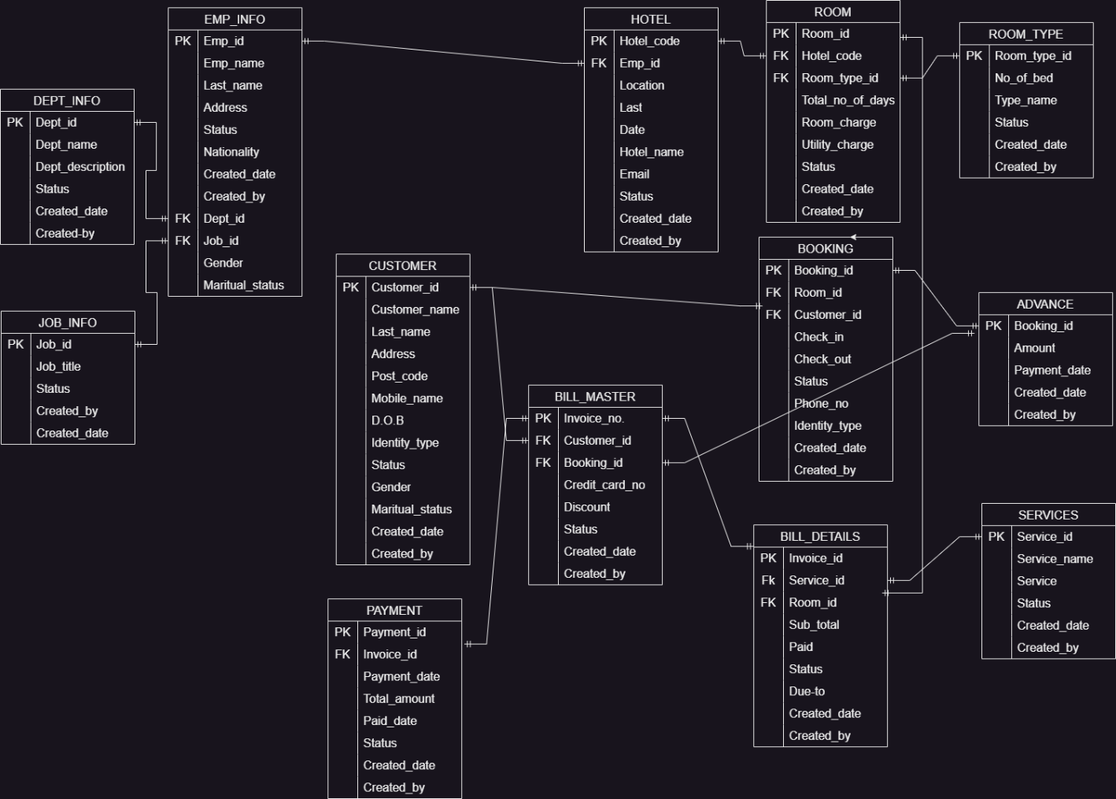

Figure 5.6.1: proposed system database design

# 

# CHAPTER SIX: SYSTEM TESTING AND IMPLIMENTATION

## 6.1: Introduction

The procedures used to install and test the computerized hotel management system are described in this chapter. The procedure included configuring the system, testing it in several ways to make sure it worked, and confirming that it complied with all requirements. Before the system was completely implemented, the testing stage was essential for finding and fixing any problems.

## 6.2: System Screenshots

Below are screenshots of key interfaces within the hotel management system:

Login form

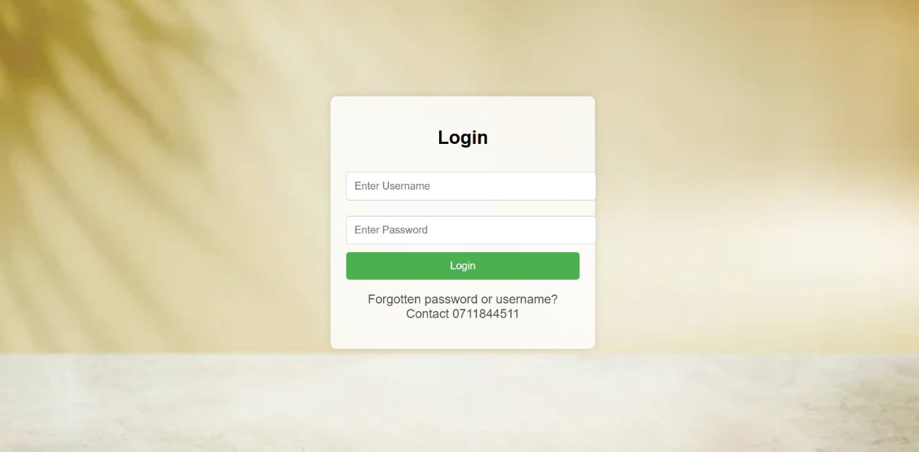

Figure 6.2.1: Login in page screenshot

Admin dashboard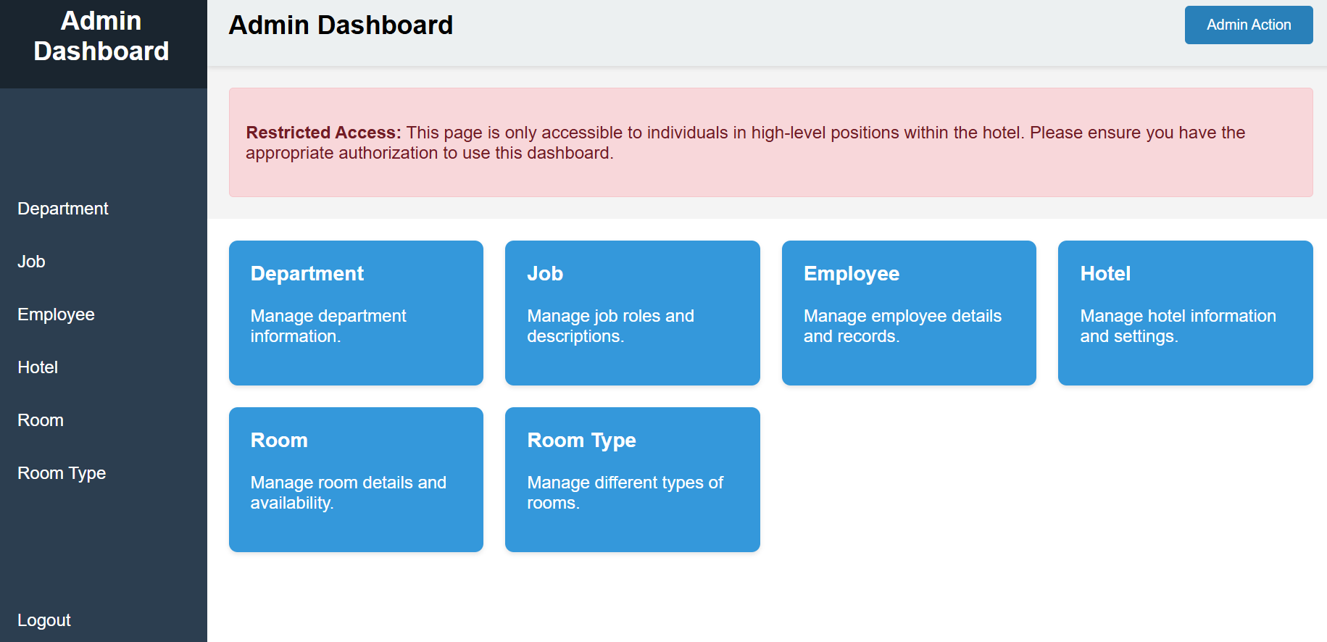

## Figure 6.2.2: Admin homepage screenshot

Department form

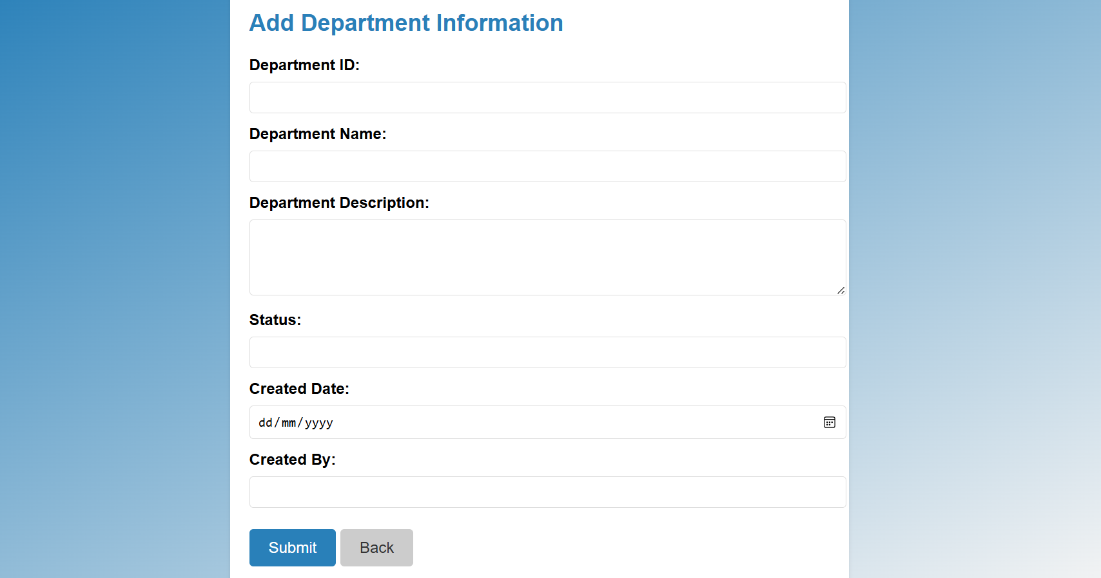 Figure 6.2.3: Department input form screenshot

**Job form**

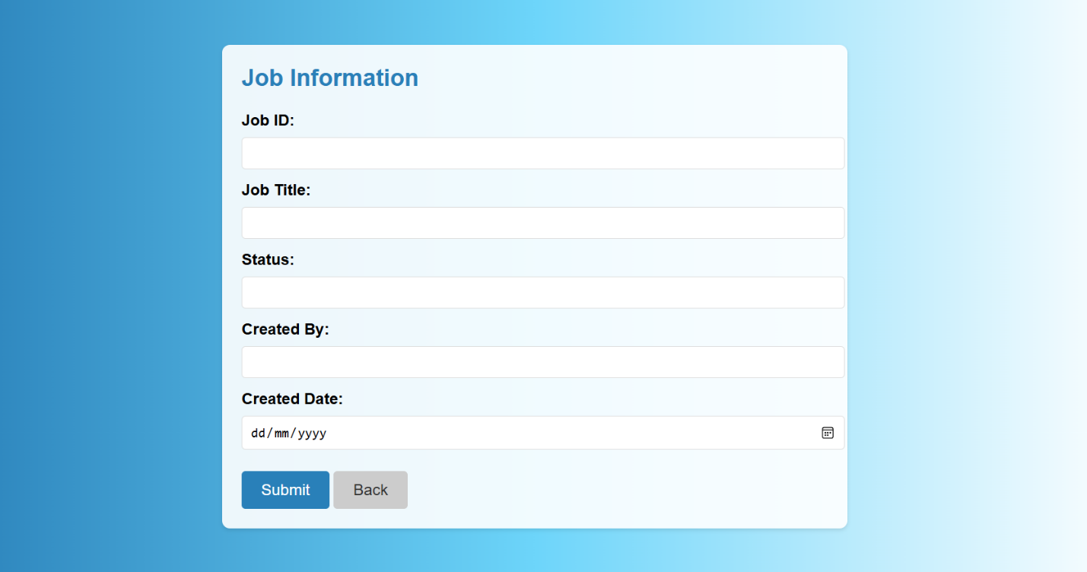

Figure 6.2.4: Job input form screenshot

**Hotel Form**

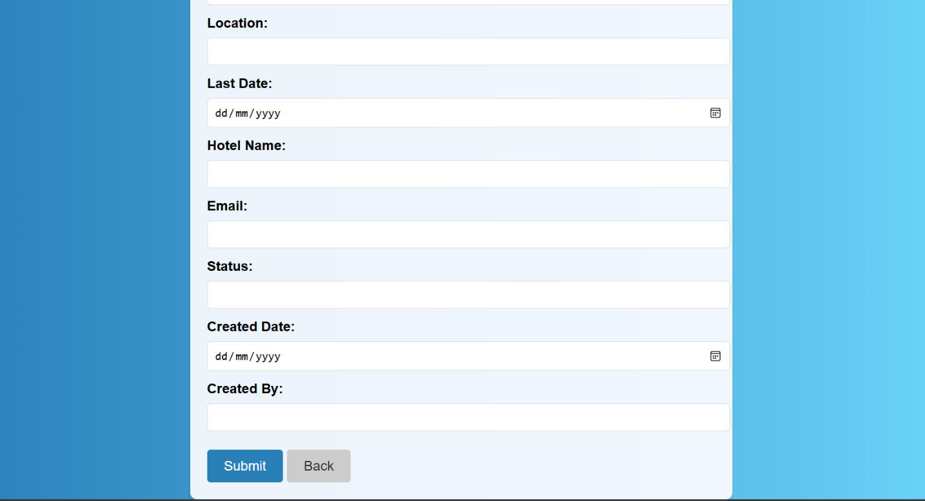

Figure 6.2.5: Hotel input form screenshot

**Room Form**

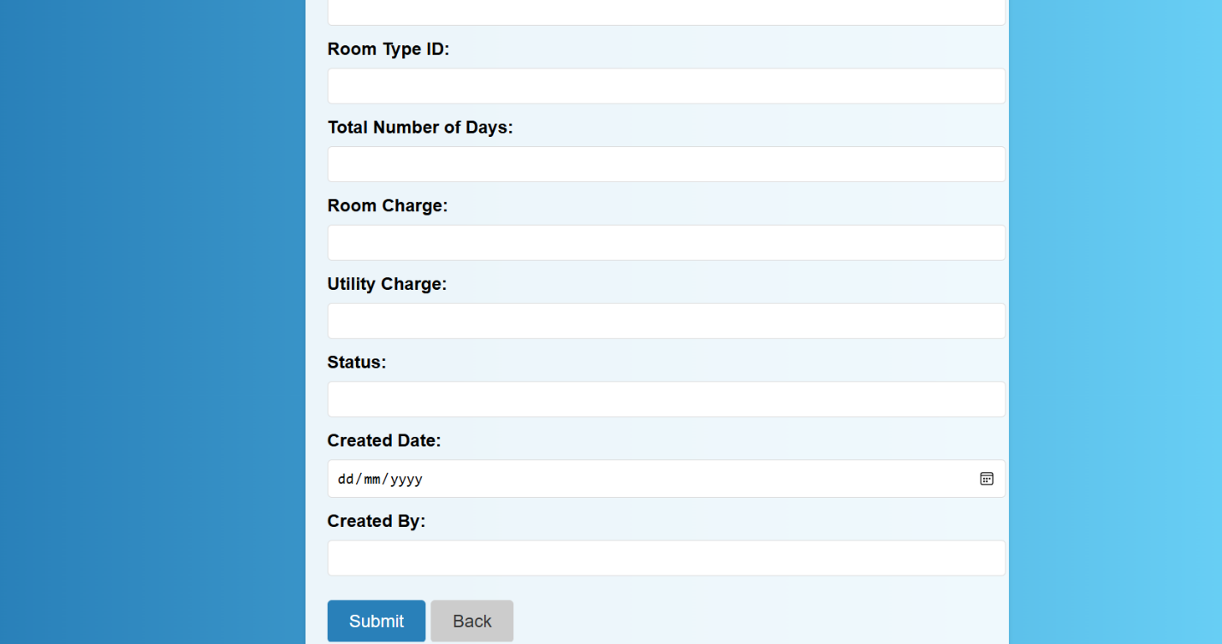Figure 6.2.6: Room input form dashboard

**Room type form**

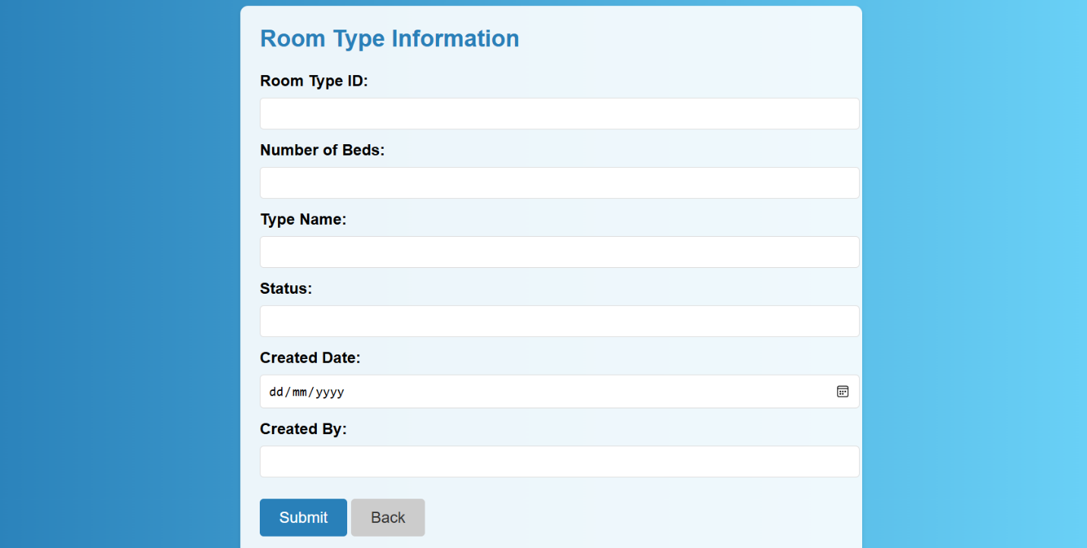Figure 6.2.7: Room type input form screenshot

**Staff dashboard**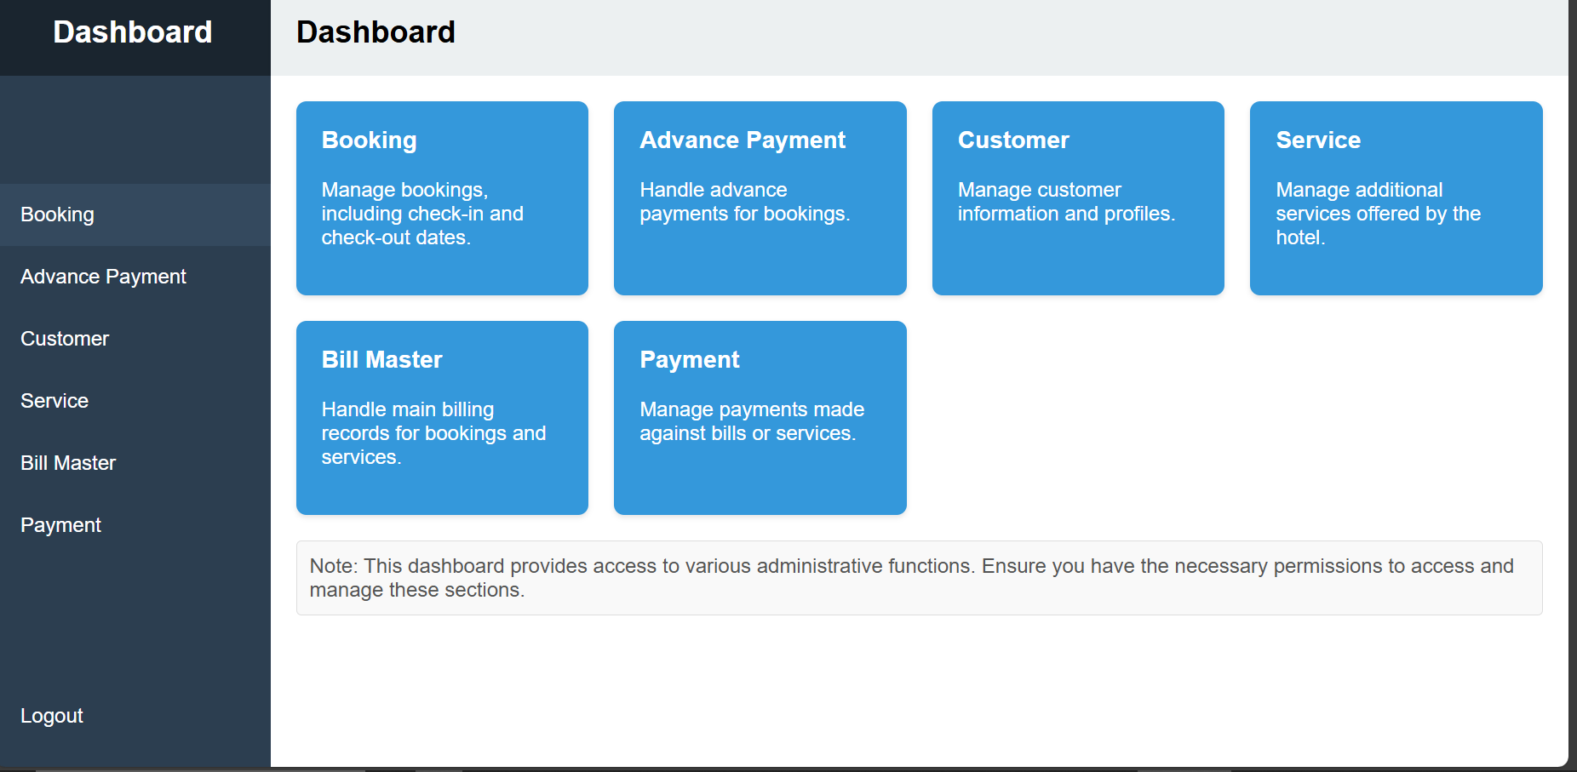Figure 6.2.8: Staff dashboard input form screenshot

**Booking form**

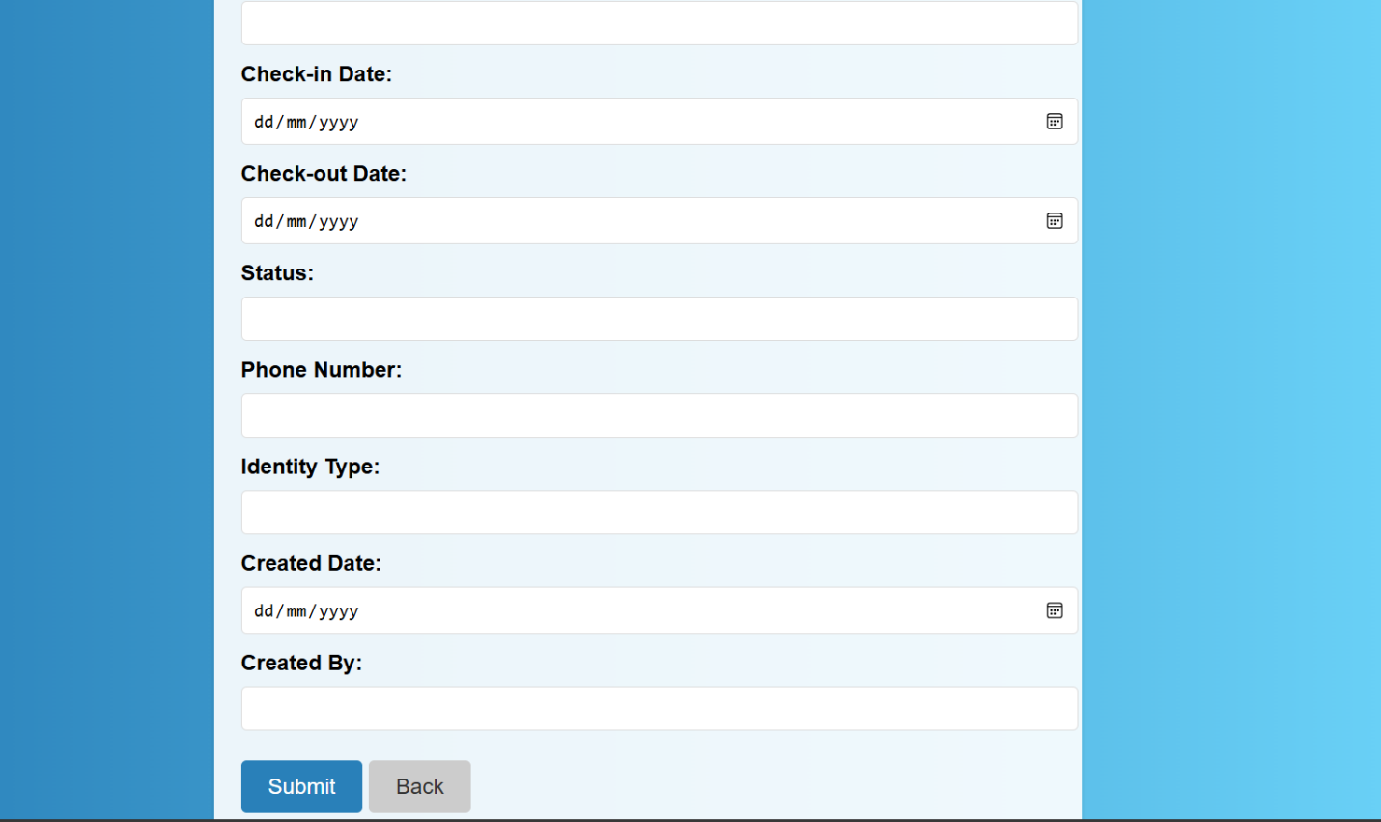Figure 6.2.9: Booking input form screenshot

**Advance payment form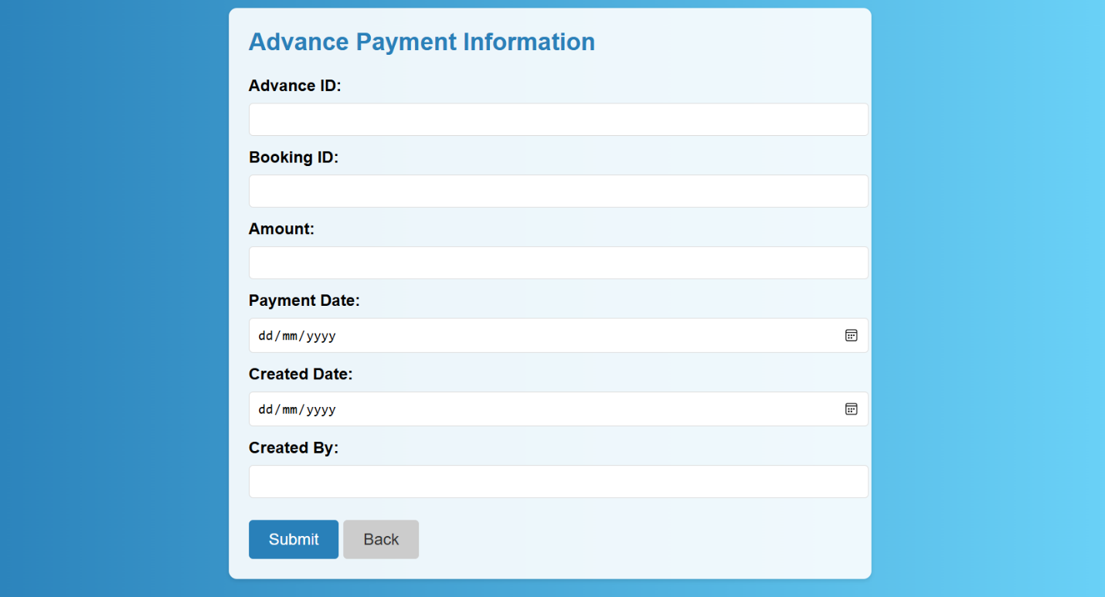**Figure 6.2.10: Advance pay input form screenshot

**Customer form**

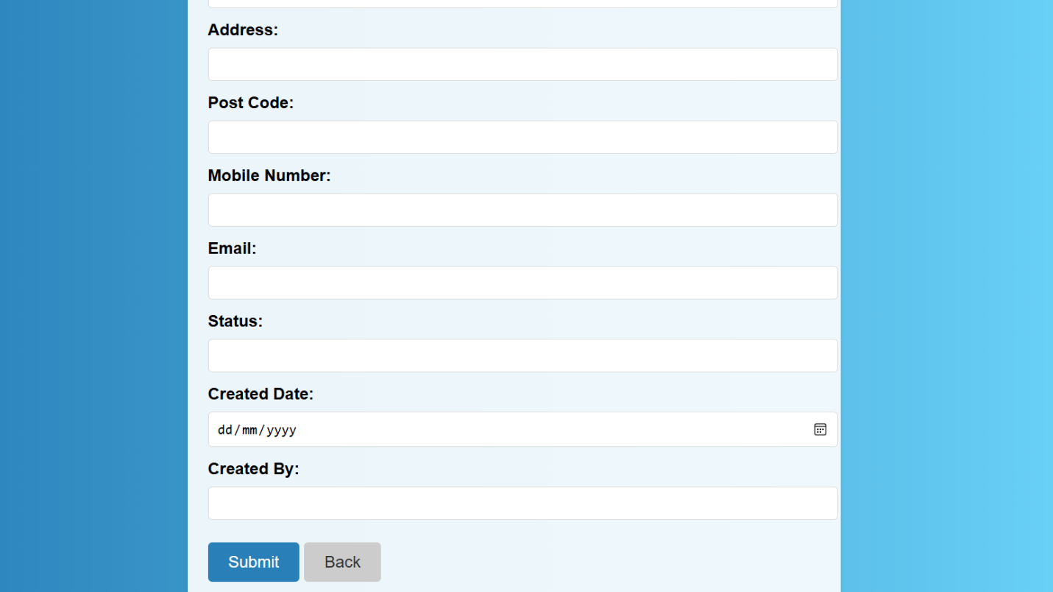

Figure 6.2.11: Customer input form screenshot

**Service form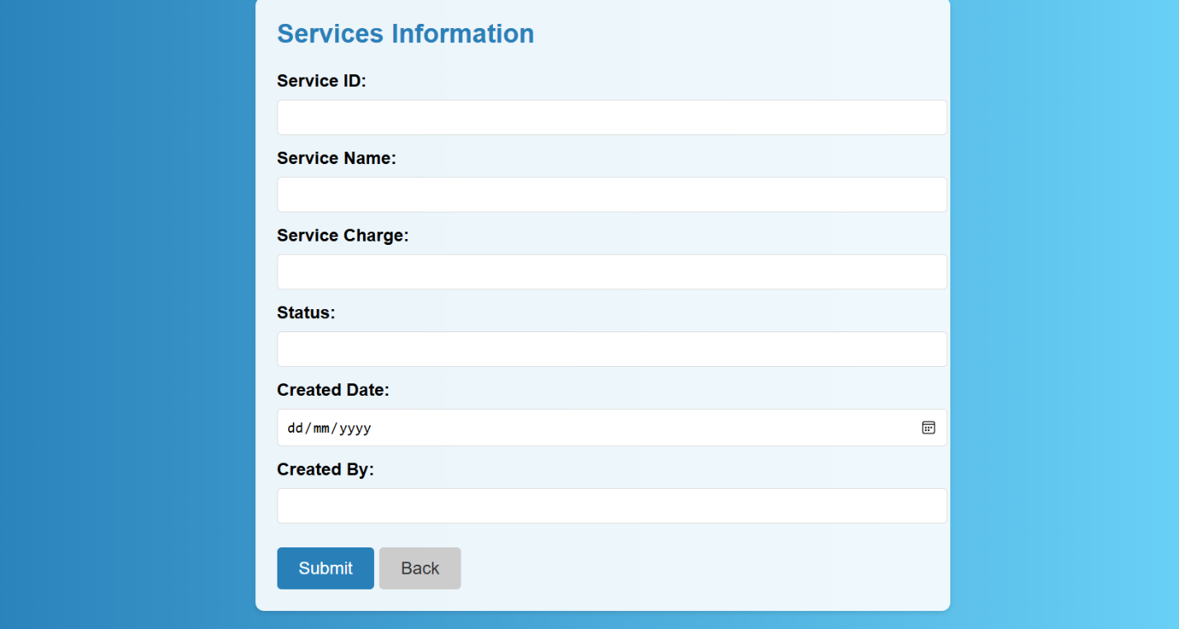**Figure 6.2.12: Service form input

**Bill master form**

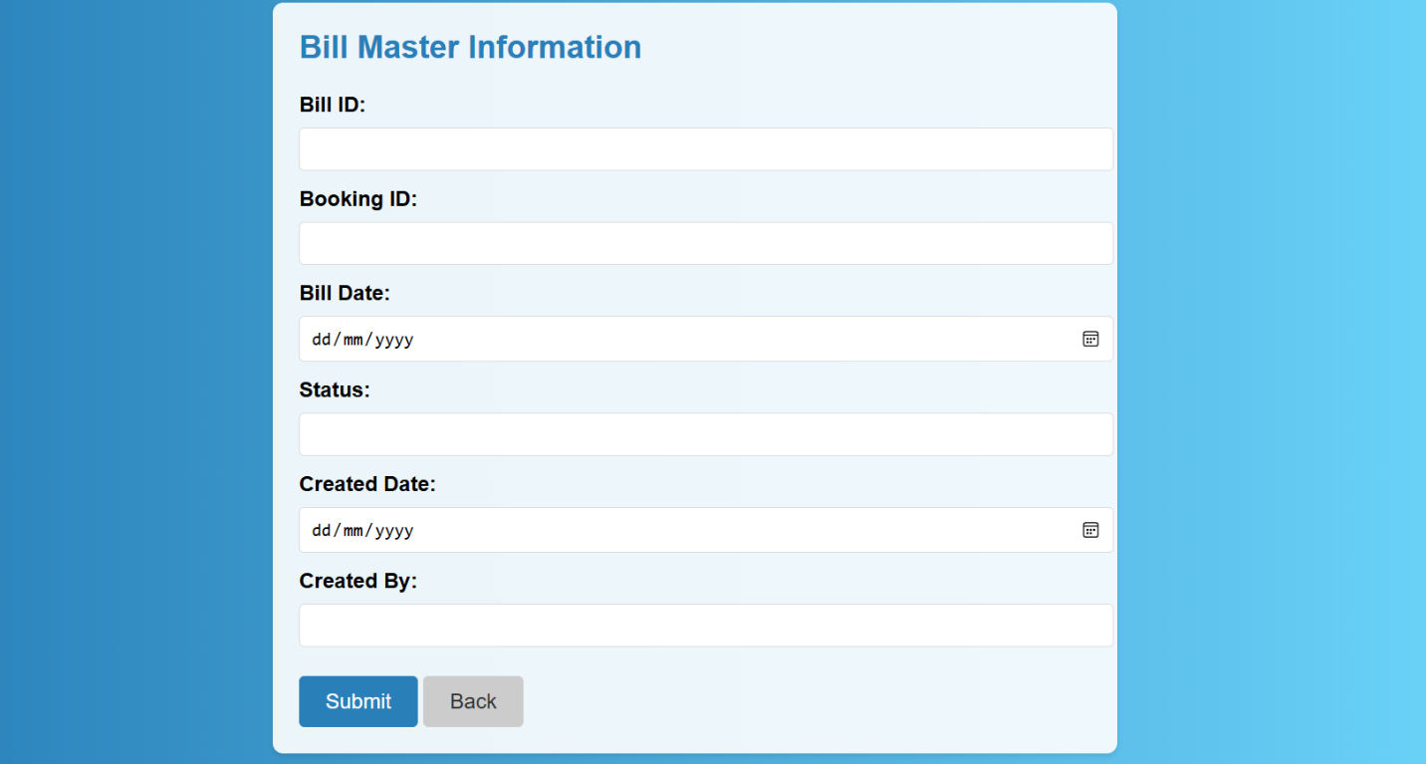

Figre 6.2.13: Bill master input form screenshot

## 6.3: Outline of the Testing Strategy

To specify the resources, methodology, timetable, and scope of each testing task, the Software Test Plan (STP) was created. It was created with the intention of guaranteeing that the system satisfies all stated functional and design requirements. The STP consists of:

* determining which features and modules need to be tested.
* defining the kinds of tests that will be carried out, like system and unit tests.
* distributing testing duties to particular employees.
* arranging testing procedures to guarantee prompt completion.

## 6.4: The Software Test Plan's Goals

The software test plan's primary objectives were:

to confirm that the system's code adheres to the stated functional and design requirements and operates as intended.

to create guidelines for carrying out system and unit testing.

to determine the procedures for testing the integration and functionality of the system.

## 6.5: Conclusion

This chapter included a full description of the hotel management system's implementation and testing. Unit testing, integration testing, system validation, and final system implementation were all part of the process. The test plan was clearly outlined beforehand. The extensive testing made that the system was ready for deployment, completely functioning, and compliant with all standards.

# CHAPTER SEVEN: CONCLUSION, FINDINGS AND RECOMMENDATION

## 7.1: Introduction

This chapter offers a thorough summary of the major results, discoveries, and suggestions that came from the computerized hotel management system's implementation and assessment. We'll talk about the system's effect on hotel operations, the difficulties we had in developing and implementing it, and possible directions for future development.

## 7.2: Conclusion

Simplifying hotel operations has been made easier thanks in large part to the computerised hotel management system. Through the integration of many functionalities, including booking management, the system has improved accuracy and efficiency. Routine task automation has decreased human error, enhanced service delivery, and given decision-makers access to real-time data. All things considered, the system has improved operational workflows and raised customer satisfaction.

## 7.3: Challenges encountered

Technical Integration Problems: The system's integration with the hardware and software from the legacy systems proved difficult and required a lot of customization and troubleshooting.

User Resistance: The new system's early acceptance was delayed because some staff members were reluctant to use it because they were unfamiliar with technology.

Data migration: Ensuring the safe and efficient transfer of data from manual records and outdated systems was necessary to minimize the risk of data loss.

Budgetary Restrictions: The system's capabilities may have been further expanded by implementing some advanced features, however budgetary constraints prevented this from happening.

Training Requirements: Time and money were needed for thorough training in order to guarantee that all users could use the system to its full potential.

## 7.4: Future recommendations

Periodic System Reviews: To find and fix any new problems or inefficiencies, the system's performance should be regularly assessed.

Ongoing Training Programs: To make sure that employees are competent with the system and able to adjust to new upgrades or features, regular training sessions should be held.

System Scalability: As the hotel grows or new technologies are developed, the system should be built with scalability in mind, making it simple to integrate new features or modules..

Workshops and Training: Setting up workshops and training sessions centred on project management and system development would provide students the abilities and information needed to take on challenging tasks.

## 7.5: Chapter summary

conclusion, the computerized hotel management system's evaluation and deployment have brought to light the difficulties faced during the project as well as its revolutionary effects. The system's automation of repetitive processes and provision of real-time data for well-informed decision-making have greatly increased the accuracy and efficiency of hotel operations. Despite these achievements, the project encountered a number of difficulties that had an impact on the project's timeline and the system's overall quality. These difficulties included inadequate monitoring, a lack of professional assistance, and technological integration problems.

# APPENDICES

# Appendix I: Sample Questionnaire

1. **How often do you stay at a hotel?**
   * Once a month
   * 2-3 times a year
   * Once a year
   * Less frequently
2. **What type of room do you usually book?**
   * Standard Room
   * Deluxe Room
   * Suite
   * Family Room
   * Other (please specify)
3. **How satisfied are you with your most recent hotel stay?**
   * Very satisfied
   * Somewhat satisfied
   * Neutral
   * Somewhat dissatisfied
   * Very dissatisfied
4. **What factors are most important to you when choosing a hotel? (Select all that apply)**
   * Price
   * Location
   * Amenities (e.g., pool, gym)
   * Room size
   * Customer reviews
   * Star rating
   * Hotel brand
5. **Have you ever encountered any issues during your hotel stay? If yes, please describe.**
   * Yes, there was an issue with the room cleanliness
   * Yes, the check-in process was slow
   * Yes, the staff was unhelpful
   * Yes, other (please specify)
   * No, I have not encountered any issues
6. **Do you prefer a hotel with a restaurant on-site or nearby dining options?**
   * On-site restaurant
   * Nearby dining options
   * No preference
7. **Which amenities do you consider essential when booking a hotel? (Select all that apply)**
   * Free Wi-Fi
   * Complimentary breakfast
   * Swimming pool
   * Fitness center
   * Business center
   * Spa services
   * Room service
   * Parking
8. **How important is the check-in/check-out experience to you?**
   * Very important
   * Somewhat important
   * Neutral
   * Not very important
   * Not at all important
9. **Which additional services do you value in a hotel? (Select all that apply)**
   * Airport shuttle service
   * Concierge services
   * Early check-in/late check-out
   * Room upgrades
   * Loyalty programs
   * Event/meeting spaces
10. **Is there anything you would like to see improved in hotel services in the future?**
    * Better time management during check-in/check-out
    * Enhanced room cleanliness
    * More flexible booking options
    * Additional amenities
    * Improved customer service
11. **Are you willing to pay extra for premium services like early check-in or room upgrades?**
    * Yes
    * No
12. **When do you typically book hotel stays? (Select all that apply)**
    * For business trips
    * For vacation/leisure
    * For family events
    * For short stays
    * For special occasions (e.g., weddings, anniversaries)
13. **Which payment method do you prefer for hotel bookings?**
    * Credit card
    * Debit card
    * Mobile payment (e.g., Mpesa)
    * Cash
    * Other (please specify)
14. **How likely are you to recommend this hotel to a friend or colleague?**
    * Extremely likely
    * Very likely
    * Moderately likely
    * Slightly likely
    * Not at all likely
15. **On average, how much do you spend per night on a hotel stay? (Select all that apply)**
    * Below 1500
    * 1500-3000
    * Above 3000
16. **Is there any specific feature or service you wish hotels offered?**
    * More dining options
    * Personalized room settings (e.g., temperature, lighting)
    * Enhanced security features
    * Contactless check-in/check-out
    * Other (please specify)
17. **How do you primarily discover new hotels for your stays?**
    * Online search
    * Recommendations from friends/family
    * Social media
    * Travel blogs and reviews
    * Promotions and advertisements
18. **When booking a hotel, which factors are deal-breakers for you? (Select all that apply)**
    * High room rates
    * Poor customer service
    * Lack of cleanliness
    * Limited amenities
    * Inconvenient location
    * Other (please specify)
19. **What additional services would you like to see in a hotel management system? (Select all that apply)**
    * Real-time room availability
    * Mobile app for bookings and services
    * Personalized stay recommendations
    * Integrated loyalty programs
    * In-app customer support
    * Other (please specify)

## Appendix 2: Sample code

## Sample code

Database connection code

<?php

$host = '127.0.0.1'; *// Server name*

$db = 'hotel_management_system'; *// Replace with your database name*

$user = 'root'; *// Your database username*

$pass = ''; *// Your database password (empty if no password)*

try {

*// Create a new PDO instance*

    $pdo = new **PDO**("mysql:host=$host;dbname=$db;charset=utf8mb4", $user, $pass);

*// Set error mode to exception*

    $pdo->**setAttribute**(**PDO**::ATTR_ERRMODE, **PDO**::ERRMODE_EXCEPTION);

} catch (**PDOException** $e) {

**echo** "Connection failed: " . $e->**getMessage**();

}

?>

Service php

<?php

include 'db.php';

if ($_SERVER['REQUEST_METHOD'] == 'POST') {

    $service_id = $_POST['service_id'];

    $service_name = $_POST['service_name'];

    $service_charge = $_POST['service_charge'];

    $status = $_POST['status'];

    $created_date = $_POST['created_date'];

    $created_by = $_POST['created_by'];

    $sql = "INSERT INTO services (service_id, service_name, service_charge, status, created_date, created_by)

            VALUES (:service_id, :service_name, :service_charge, :status, :created_date, :created_by)";

    $stmt = $pdo->**prepare**($sql);

    $stmt->**execute**([

        ':service_id' => $service_id,

        ':service_name' => $service_name,

        ':service_charge' => $service_charge,

        ':status' => $status,

        ':created_date' => $created_date,

        ':created_by' => $created_by

    ]);

**echo** "Service information added successfully.";

}

?>

Room type php

<?php

include 'db.php';

if ($_SERVER['REQUEST_METHOD'] == 'POST') {

    $room_type_id = $_POST['room_type_id'];

    $no_of_bed = $_POST['no_of_bed'];

    $type_name = $_POST['type_name'];

    $status = $_POST['status'];

    $created_date = $_POST['created_date'];

    $created_by = $_POST['created_by'];

    $sql = "INSERT INTO room_type_info (room_type_id, no_of_bed, type_name, status, created_date, created_by)

            VALUES (:room_type_id, :no_of_bed, :type_name, :status, :created_date, :created_by)";

    $stmt = $pdo->**prepare**($sql);

    $stmt->**execute**([

        ':room_type_id' => $room_type_id,

        ':no_of_bed' => $no_of_bed,

        ':type_name' => $type_name,

        ':status' => $status,

        ':created_date' => $created_date,

        ':created_by' => $created_by

    ]);

**echo** "Room type information added successfully.";

}

?>

Room php

<?php

include 'db.php';

if ($_SERVER['REQUEST_METHOD'] == 'POST') {

    $room_type_id = $_POST['room_type_id'];

    $no_of_bed = $_POST['no_of_bed'];

    $type_name = $_POST['type_name'];

    $status = $_POST['status'];

    $created_date = $_POST['created_date'];

    $created_by = $_POST['created_by'];

    $sql = "INSERT INTO room_type_info (room_type_id, no_of_bed, type_name, status, created_date, created_by)

            VALUES (:room_type_id, :no_of_bed, :type_name, :status, :created_date, :created_by)";

    $stmt = $pdo->**prepare**($sql);

    $stmt->**execute**([

        ':room_type_id' => $room_type_id,

        ':no_of_bed' => $no_of_bed,

        ':type_name' => $type_name,

        ':status' => $status,

        ':created_date' => $created_date,

        ':created_by' => $created_by

    ]);

**echo** "Room type information added successfully.";

}

?>

Payment php

<?php

include 'db.php';

if ($_SERVER['REQUEST_METHOD'] == 'POST') {

    $payment_id = $_POST['payment_id'];

    $bill_id = $_POST['bill_id'];

    $payment_date = $_POST['payment_date'];

    $amount = $_POST['amount'];

    $status = $_POST['status'];

    $created_date = $_POST['created_date'];

    $created_by = $_POST['created_by'];

    $sql = "INSERT INTO payment (payment_id, bill_id, payment_date, amount, status, created_date, created_by)

            VALUES (:payment_id, :bill_id, :payment_date, :amount, :status, :created_date, :created_by)";

    $stmt = $pdo->**prepare**($sql);

    $stmt->**execute**([

        ':payment_id' => $payment_id,

        ':bill_id' => $bill_id,

        ':payment_date' => $payment_date,

        ':amount' => $amount,

        ':status' => $status,

        ':created_date' => $created_date,

        ':created_by' => $created_by

    ]);

**echo** "Payment information added successfully.";

}

?>

Job php

<?php

include 'db.php'; *// Include your database connection file*

if ($_SERVER['REQUEST_METHOD'] == 'POST') {

*// Retrieve form data*

    $job_title = $_POST['job_title'];

    $status = $_POST['status'];

    $created_by = $_POST['created_by'];

    $created_date = $_POST['created_date'];

*// Prepare SQL query*

    $sql = "INSERT INTO jobs (job_title, status, created_by, created_date)

            VALUES (:job_title, :status, :created_by, :created_date)";

    $stmt = $pdo->**prepare**($sql);

*// Execute query with bound parameters*

    try {

        $stmt->**execute**([

            ':job_title' => $job_title,

            ':status' => $status,

            ':created_by' => $created_by,

            ':created_date' => $created_date

        ]);

**echo** "Job information added successfully.";

    } catch (**Exception** $e) {

**echo** "Error: " . $e->**getMessage**();

    }

}

?>

Hotel php

<?php

include 'db.php';

if ($_SERVER['REQUEST_METHOD'] == 'POST') {

    $job_id = $_POST['job_id'];

    $job_title = $_POST['job_title'];

    $status = $_POST['status'];

    $created_by = $_POST['created_by'];

    $created_date = $_POST['created_date'];

    $sql = "INSERT INTO job_info (job_id, job_title, status, created_by, created_date)

            VALUES (:job_id, :job_title, :status, :created_by, :created_date)";

    $stmt = $pdo->**prepare**($sql);

    $stmt->**execute**([

        ':job_id' => $job_id,

        ':job_title' => $job_title,

        ':status' => $status,

        ':created_by' => $created_by,

        ':created_date' => $created_date

    ]);

**echo** "Job information added successfully.";

}

?>

Employee php

<?php

include 'db.php'; *// Include your database connection file*

if ($_SERVER['REQUEST_METHOD'] == 'POST') {

*// Retrieve form data*

    $emp_name = $_POST['emp_name'];

    $last_name = $_POST['last_name'];

    $address = $_POST['address'];

    $status = $_POST['status'];

    $nationality = $_POST['nationality'];

    $created_date = $_POST['created_date'];

    $created_by = $_POST['created_by'];

    $dept_id = $_POST['dept_id'];

    $job_id = $_POST['job_id'];

    $gender = $_POST['gender'];

    $marital_status = $_POST['marital_status'];

*// Prepare SQL query*

    $sql = "INSERT INTO employees (emp_name, last_name, address, status, nationality, created_date, created_by, dept_id, job_id, gender, marital_status)

            VALUES (:emp_name, :last_name, :address, :status, :nationality, :created_date, :created_by, :dept_id, :job_id, :gender, :marital_status)";

    $stmt = $pdo->**prepare**($sql);

*// Execute query with bound parameters*

    try {

        $stmt->**execute**([

            ':emp_name' => $emp_name,

            ':last_name' => $last_name,

            ':address' => $address,

            ':status' => $status,

            ':nationality' => $nationality,

            ':created_date' => $created_date,

            ':created_by' => $created_by,

            ':dept_id' => $dept_id,

            ':job_id' => $job_id,

            ':gender' => $gender,

            ':marital_status' => $marital_status

        ]);

**echo** "Employee information added successfully.";

    } catch (**Exception** $e) {

**echo** "Error: " . $e->**getMessage**();

    }

}

?>

# REFERENCES

· Kithinji, S., & Mbiti, I. M. (2020). *Adoption of technology in the hospitality industry: A case study of Kenyan hotels*. *Journal of Tourism and Hospitality Research, 15*(3), 45-60.

· Njenga, C. (2021). *The role of cloud-based property management systems in Kenyan hotels*. *International Journal of Hospitality Management, 37*(2), 112-125.

· Mwaura, P. (2019). *Impact of digital transformation on the hospitality industry in Kenya*. *African Journal of Business and Management, 11*(4), 89-101.

· Kamau, R., & Wanjiru, H. (2022). *Challenges and opportunities in hotel management systems: Insights from Kenya*. *Kenyan Journal of Hospitality and Tourism Studies, 8*(1), 22-38.

· Mwangi, J. (2023). *Sustainable practices in hotel management systems: A Kenyan perspective*. *Journal of Sustainable Tourism and Hospitality, 20*(1), 77-93.